

LUSAKA CITY COUNCIL

REPORT ON COMMUNITY ENGAGEMENT PROGRAM KANYAMA CONSTITUENCY (2025)

CONSTITUENCY DEVELOPMENT FUND (CDF) COMMUNITY ENGAGEMENT MEETINGS IN HARRY MWAANGA, MUNKOLO, CHINIKA AND KANYAMA WARD 13

SUBJECT : Community Engagement Program
CONSTITUENCY : Kanyama
LOCATION : Harry Mwaanga, Munkolo, Chinika and Kanyama Ward 13

INTRODUCTION
CDF was introduced and approved by the National Assembly in 1995 to facilitate the delivery of public goods and services to foster National development for local communities. The objective was to create an enabling environment for a holistic development at constituency level to implement projects which improve the wellbeing of the people in their constituencies.
The Scope of the CDF has expanded and its budgetary allocation increased to support Community-Centered Development, encourage entrepreneurship and promote access to education and skills development to the orphans and vulnerable community members.
The Kanyama Constituency community engagement team conducted sensitization program for eight (08) days in the four (04) of the six (06) wards. Two remaining wards will be done before the month of August comes to an end.
The community engagement team comprised of the following officers:
SN | NAME | POSITION/DEPARTMENT
1. | Felix Chama | Socio Economic Planner
2. | Namakau Pumulo | Public Relations Officer
3. | Maria C. Mulenga | Socio Economic Planner
4. | Fidelis Sinakoma | Ag. Socio Economic Planner (Intern)
5. | Margaret Ngosa | Ag. Socio Economic Planner(Intern)
6. | Bwalya Kalimanshi | Public Relations Officer
7. | Michelo | Public Relations Officer (DC’s Office)
8. | Lushomo Kalusa | Ag. Socio Economic Planner (Intern)
9. | Judy Zulu | Driver
10 | Bridget Shakakaye | WDC Chinika Ward
11. | Cecilia Naloya | WDC Kanyama Ward 13
12. | Godfrey Lungu | WDC Harry Mwaanga Ward
13. | Judith Nkatwe Mushala | WDC Munkolo Ward
14. | Munyungi Nyembula | WDC Harry Mwaanga Ward
15. | Ben Bulaya | WDC Munkolo Ward
16. | John Mfune | WDC Munkolo Ward
17. | Brian Nyirenda | WDC Harry Mwaanga Ward
18. | Musangu Muhundika | Socio Economic Planner
19. | Chikondi Simunene | Ag. Socio Economic Planner (intern)
20. | Jessy Lubemba Matatila | Socio Economic Planner

The main objective of the community engagement program was to sensitize the community on CDF, the components of CDF and the process of CDF application process for all the 3 components from submission to implementation. Listed below are the outlined notes as presented to the community in all the four (04) of the six (06) wards.
The Constituency Development Fund (CDF) has three (3) components namely:
  - Community Based Projects,
  - Youth, Women and Community Empowerment, and
  - Secondary Boarding School and Skills Development Bursaries.

SECONDARY BOARDING SCHOOL AND SKILLS DEVELOPMENT BURASARIES
The objectives of the bursaries are:
  - To enhance human development and drive the entrepreneurship agenda at the local level.
  - To provide for vulnerable learners to access Secondary Boarding Schools and Skills Training Institutions offering Technical Education, Vocational and Entrepreneurship Programs.
YOUTH, WOMEN AND COMMUNITY EMPOWERMENT
- Promotes apprenticeship, mentorship and business development services to support enterprise development and creation of market linkages.
- Equip beneficiaries with money in form of grants given to organised groups, clubs and cooperatives that have a minimum of ten members.
- Equip cooperatives and individuals to establish small and medium scale business with empowerment loans.
COMMUNITY BASED PROJECTS
- Community Projects shall address challenges of inadequate infrastructure, such as: Water and Sanitation Points, Schools, Health Facilities, Police Posts, Feeder Roads, Market Shelters, Crossing Points, Canals and Dip Tanks etc.
- Project application forms shall be obtained from the local authority, parliamentary constituency and the Ward Development Committee (WDC) office.
REQUIREMENTS FOR CDF COMPONENTS
SKILLS DEVELOPMENT BUSARIES:

- Criteria and requirements for one to access skills development bursaries;

SN | REQUIREMENTS
1 | Must be between 16 and 35 years of age.
2 | Acceptance letter from a TEVETA Accredited Training Institution.
3 | Recommendation letter from a clergy or civic leader.
4 | Should be a Zambian with a Green National Registration Card.
5 | Should be a resident of the particular constituency for more than 6 months.
6 | Entrepreneurs that need up scaling and re skilling.

SECONDARY BOARDING BURSARY:

- Criteria and requirements for one to access secondary boarding bursaries;

SN | REQUIREMENTS
1 | Should have an acceptance from a GRZ /Missionary boarding School.
2 | Recommendation letter from a clergy or civic leader or Head of previous school.
3 | Attach NRCs and contact information of Parents/Guardians.
4 | Should be a resident of the particular constituency for more than 6 months.

NB: Attach any of the following documents:-
- Death certificates/ burial permit of parents/guardians.
- or letter from traditional leadership confirming the death of parents/ guardians
- or disability card or letter from the hospital.

LOANS:

- Criteria and requirements for one to access loans;

SN | REQUIREMENTS
1 | Must have a registered company with PACRA/ Registrar of Societies.
2 | Must have a viable business proposal (to be approved by the bank).
3 | Proof of Bank account suggested by the constituency.
4 | The proposals should provide employment opportunities.
5 | The proposed project must be undertaken within the particular constituency.
6 | Should be a resident of the particular constituency for more than 6 months.

GRANTS:

- Criteria and requirements for one to access grants;

SN | REQUIREMENTS
1 | Must have a registered club/organised group/cooperative registered with PACRA/ Registrar of Societies/Local Authority.
2 | Must have a viable business proposal.
3 | Should have minutes to prove that they sit as a club/cooperative time and again.
4 | Should be a resident of the particular constituency for more than 6 months.
5 | The proposed project must be undertaken within the particular constituency.
6 | Proof of Bank account suggested by the constituency.
7 | Must have a minimum of 10 members with valid Green NRCs.

COMMUNITY PROJECTS:

- Criteria and requirements for one to access community projects;

SN | REQUIREMENTS
1 | The WDCs shall prepare meetings with the zonal leaders (the projects shall be in line with the Ward Development plan, Integrated Development Plan (IDP), any other Local Development Framework. In the absence of such plans, community needs shall inform the criteria for identification of projects.
2 | Any potential Bidders can visit the procurement office at the civic centre to be oriented on the use of the mandatory eGP (electronic government procurement) platform.
3 | The proposed community project must be undertaken within the particular constituency.

CONCLUSION
The community engagement meetings were fruitful and with the increase in the scope of the Constituency Development Fund (CDF), both financially and in terms of the volume of activities to be covered, it calls for increased capacity and/or awareness on the part of the Constituency Development Fund Committee and all involved stakeholders in the administration of CDF. There is also need to establish the WDC offices in all the wards as this will enhance community engagement and easy accessibility of information from application to submission of all CDF components.
Find attached the pictures as captured by PR for all the community engagement meetings conducted in all the four (04) of the six (06) wards.
Signed by:
Ronald Ngala Maria C. Mulenga
DPO SEP

_______________________ _____________________

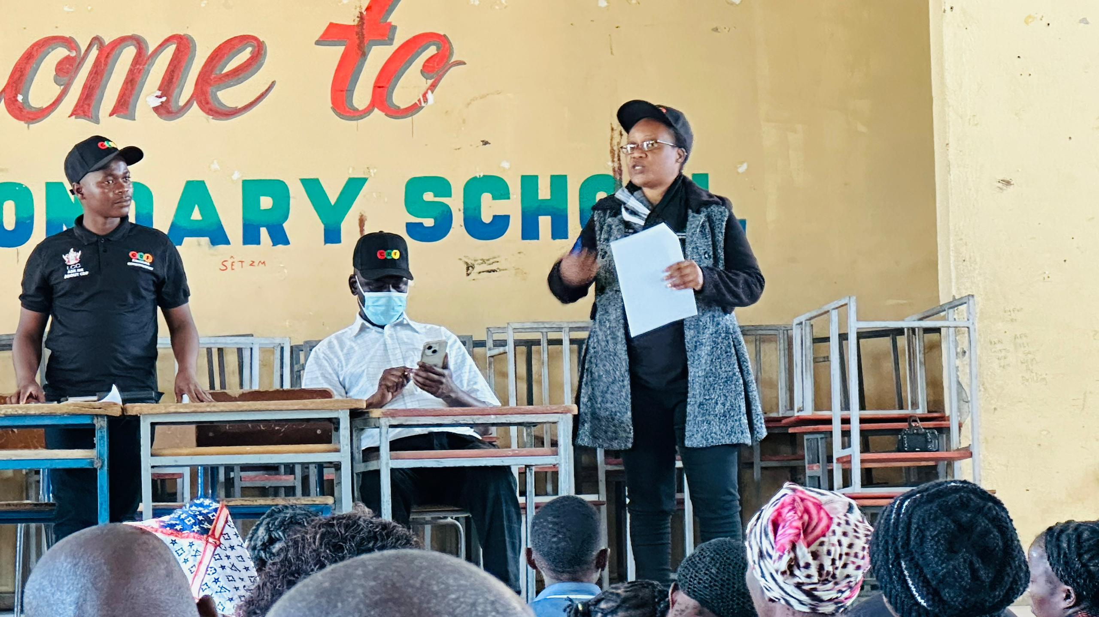

The Socio Economic Planner with team members presenting the CDF components to the community of Chinika ward.
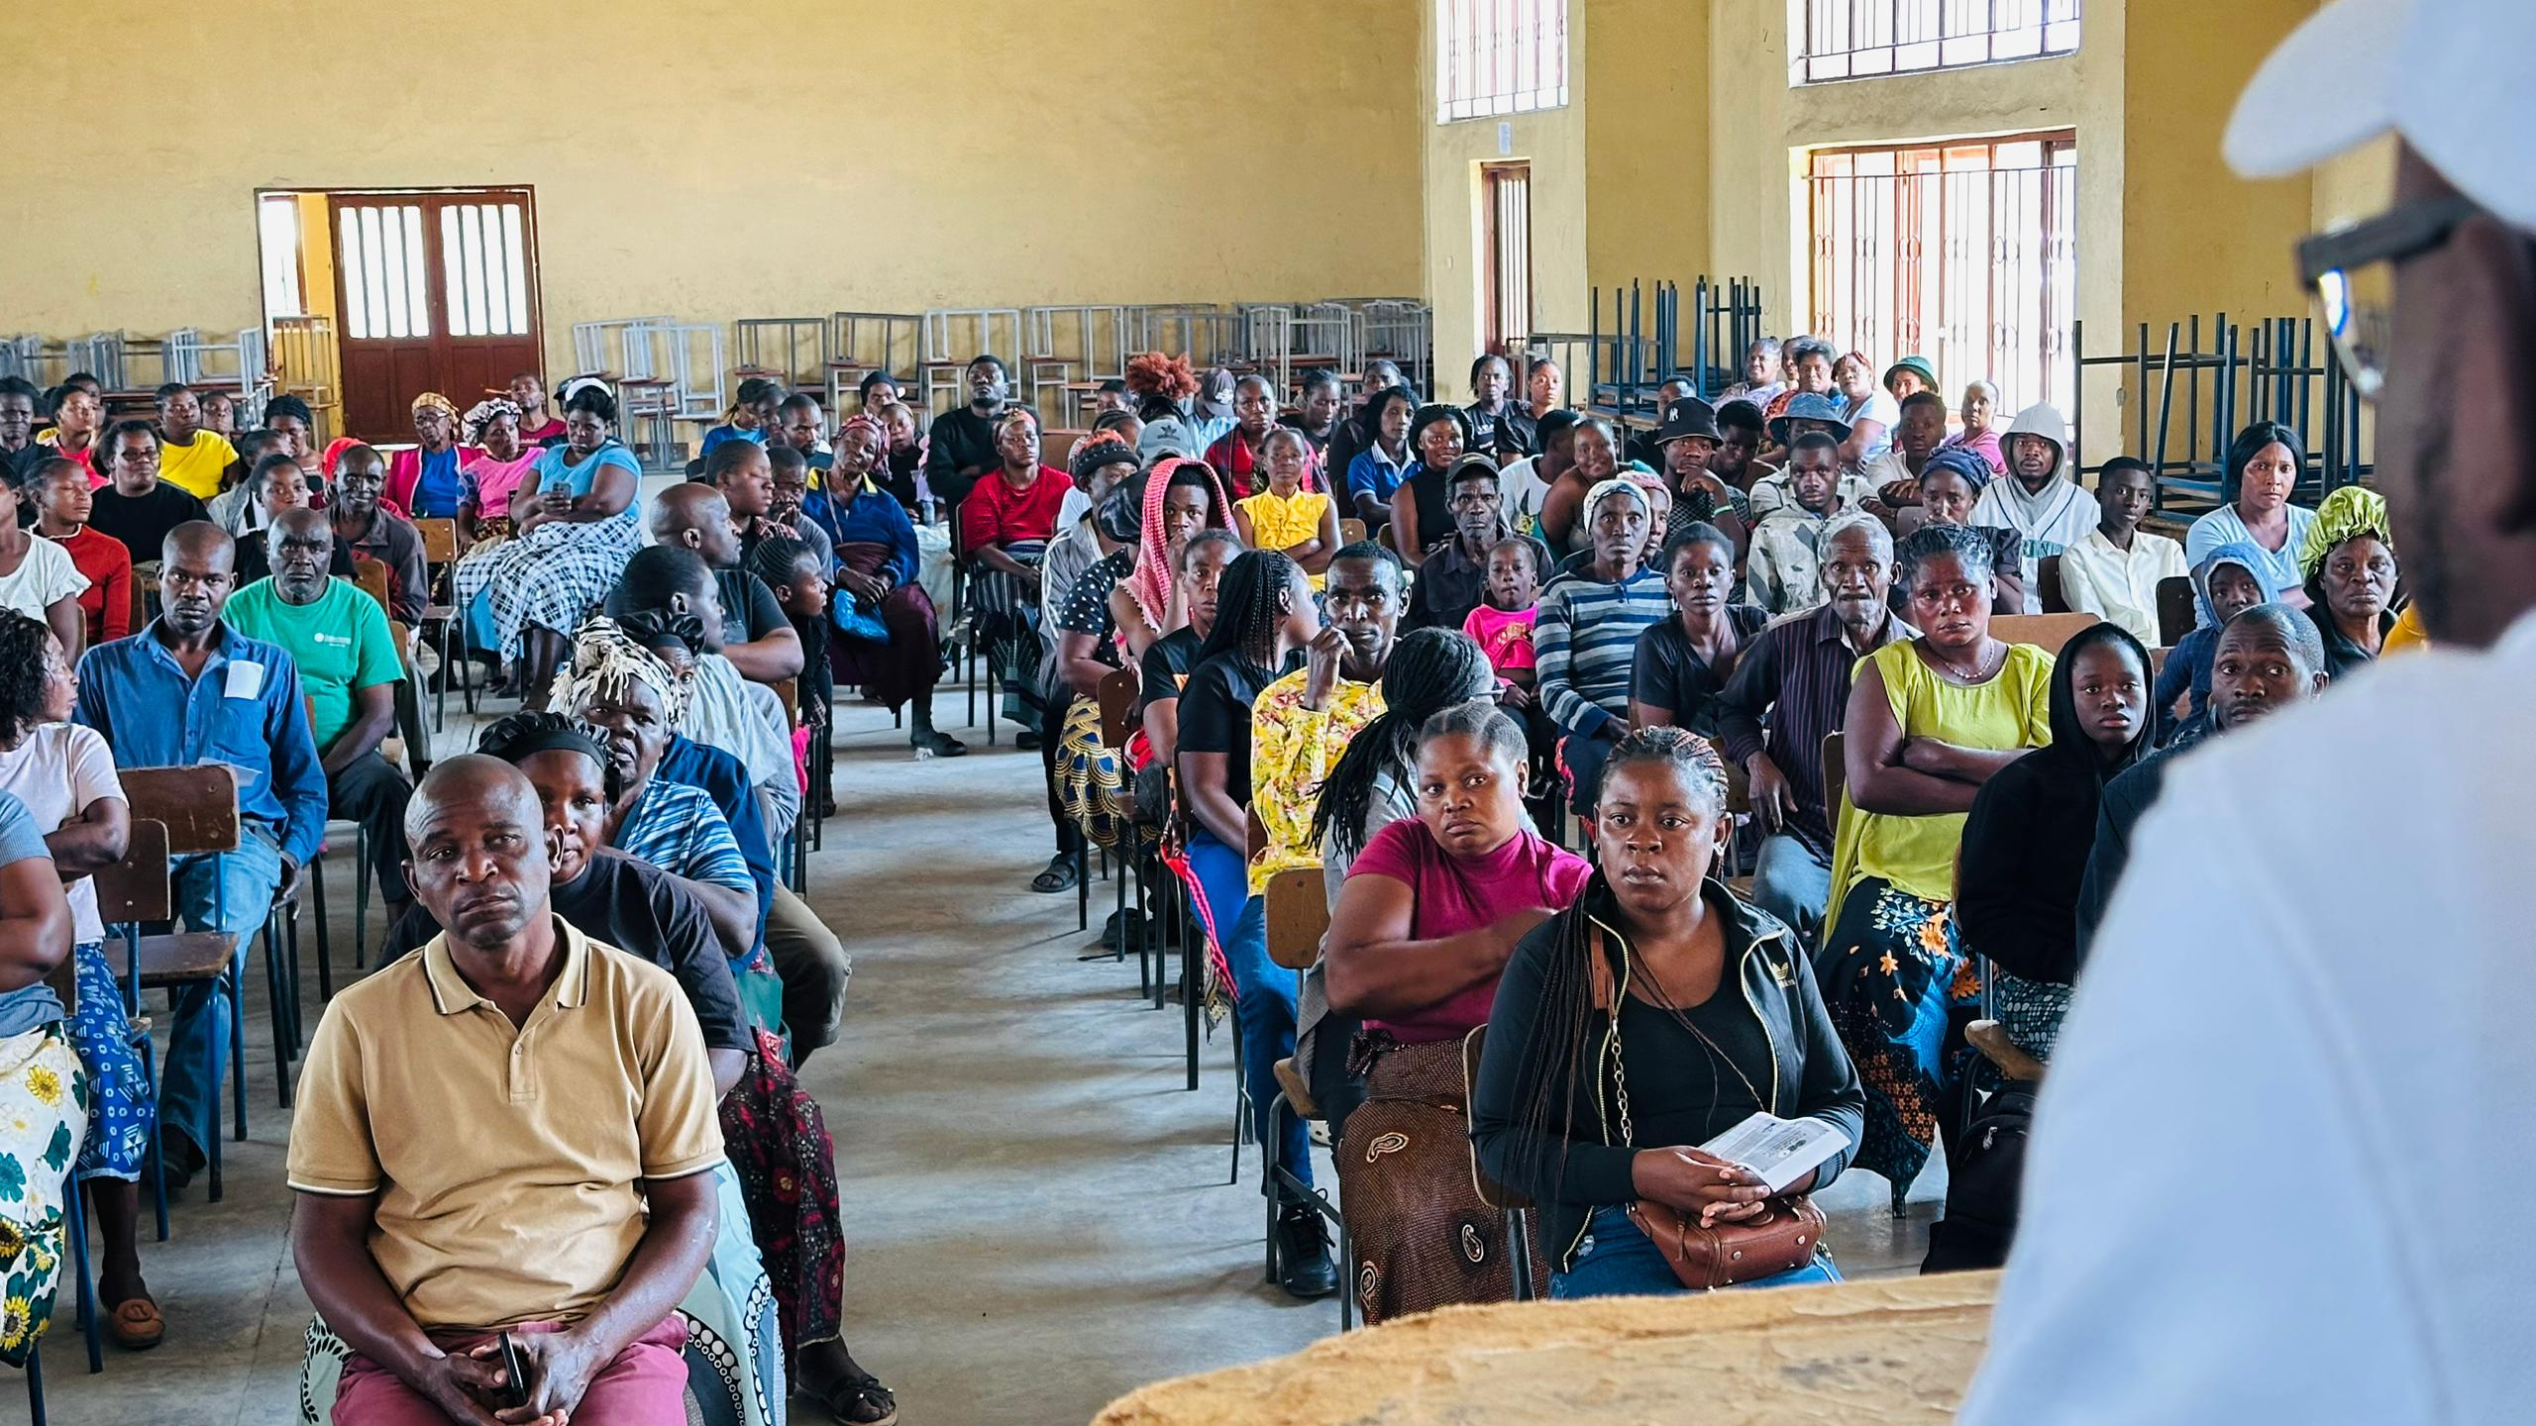
The youths within Chinika ward turned up to enquire more about CDF and testify.
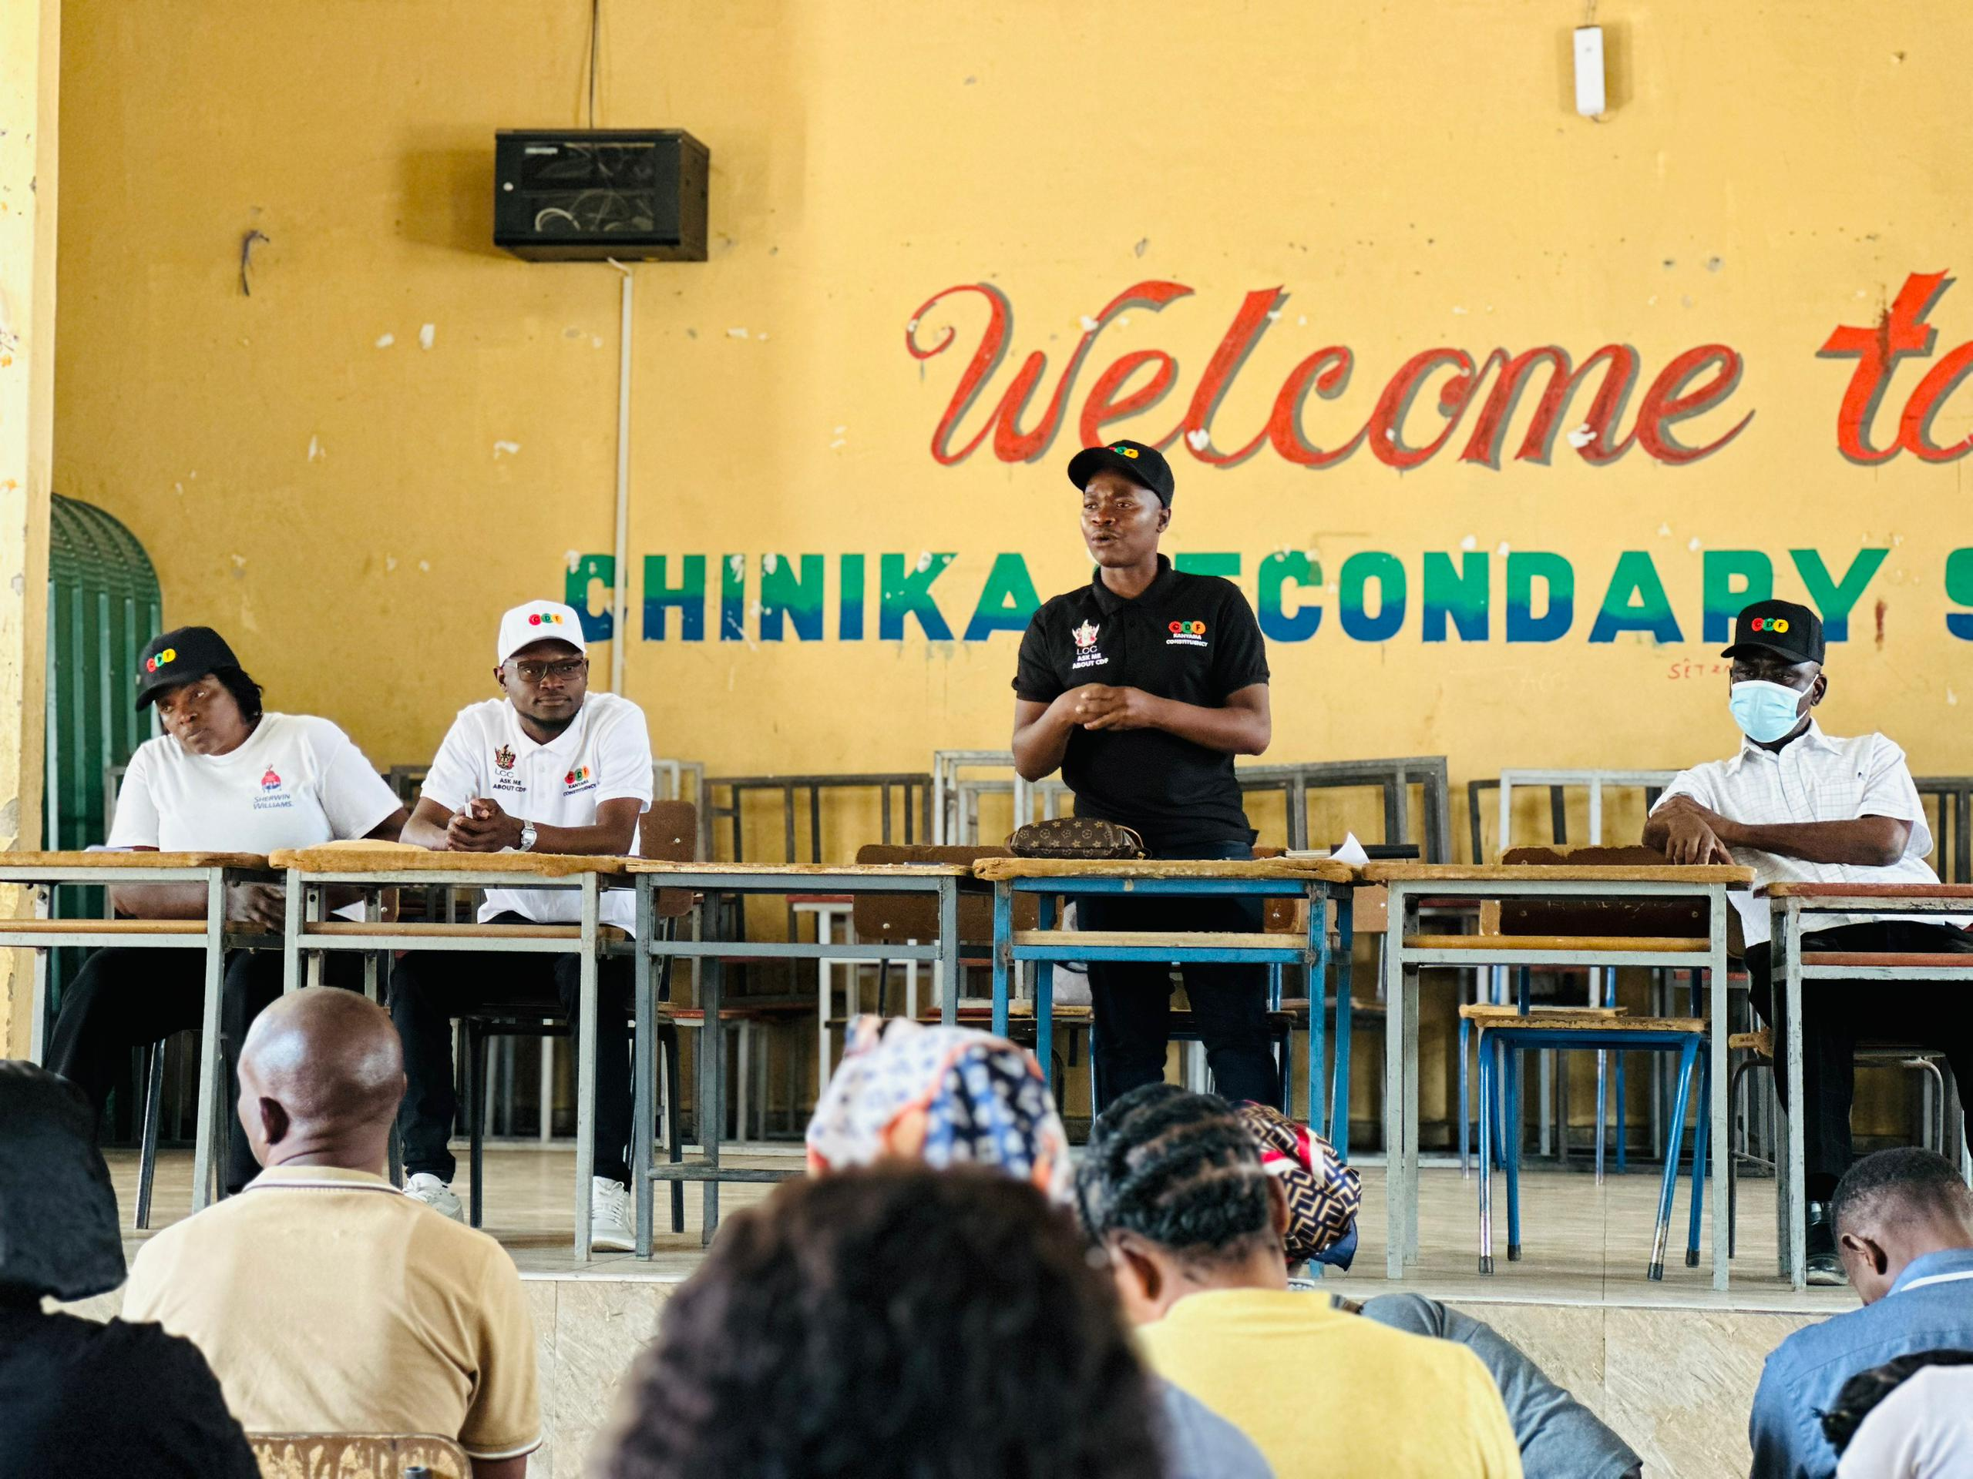
The public relations officer from the office of the District Commissioner, alongside the sitted team members from the local authority and the WDC.
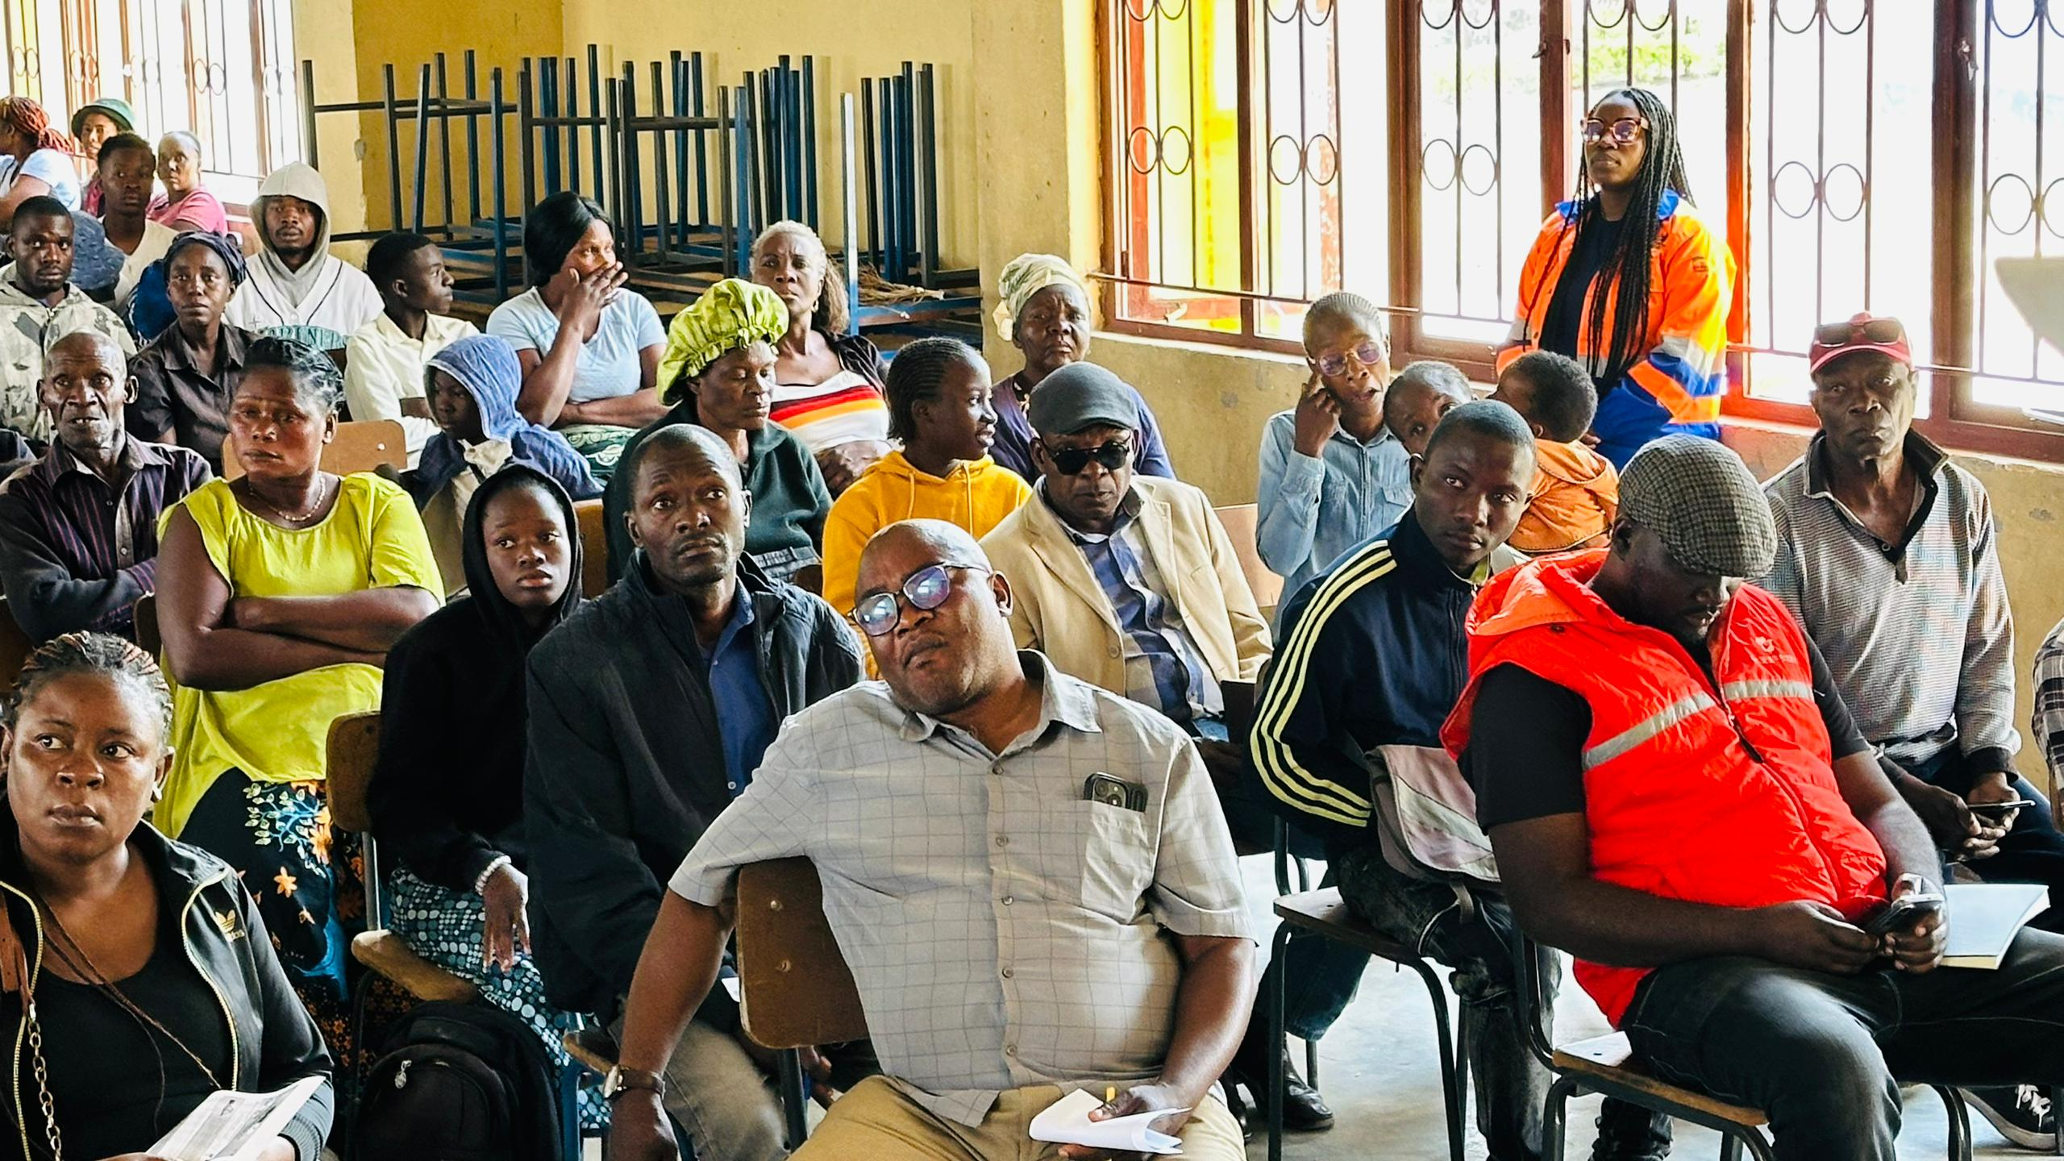
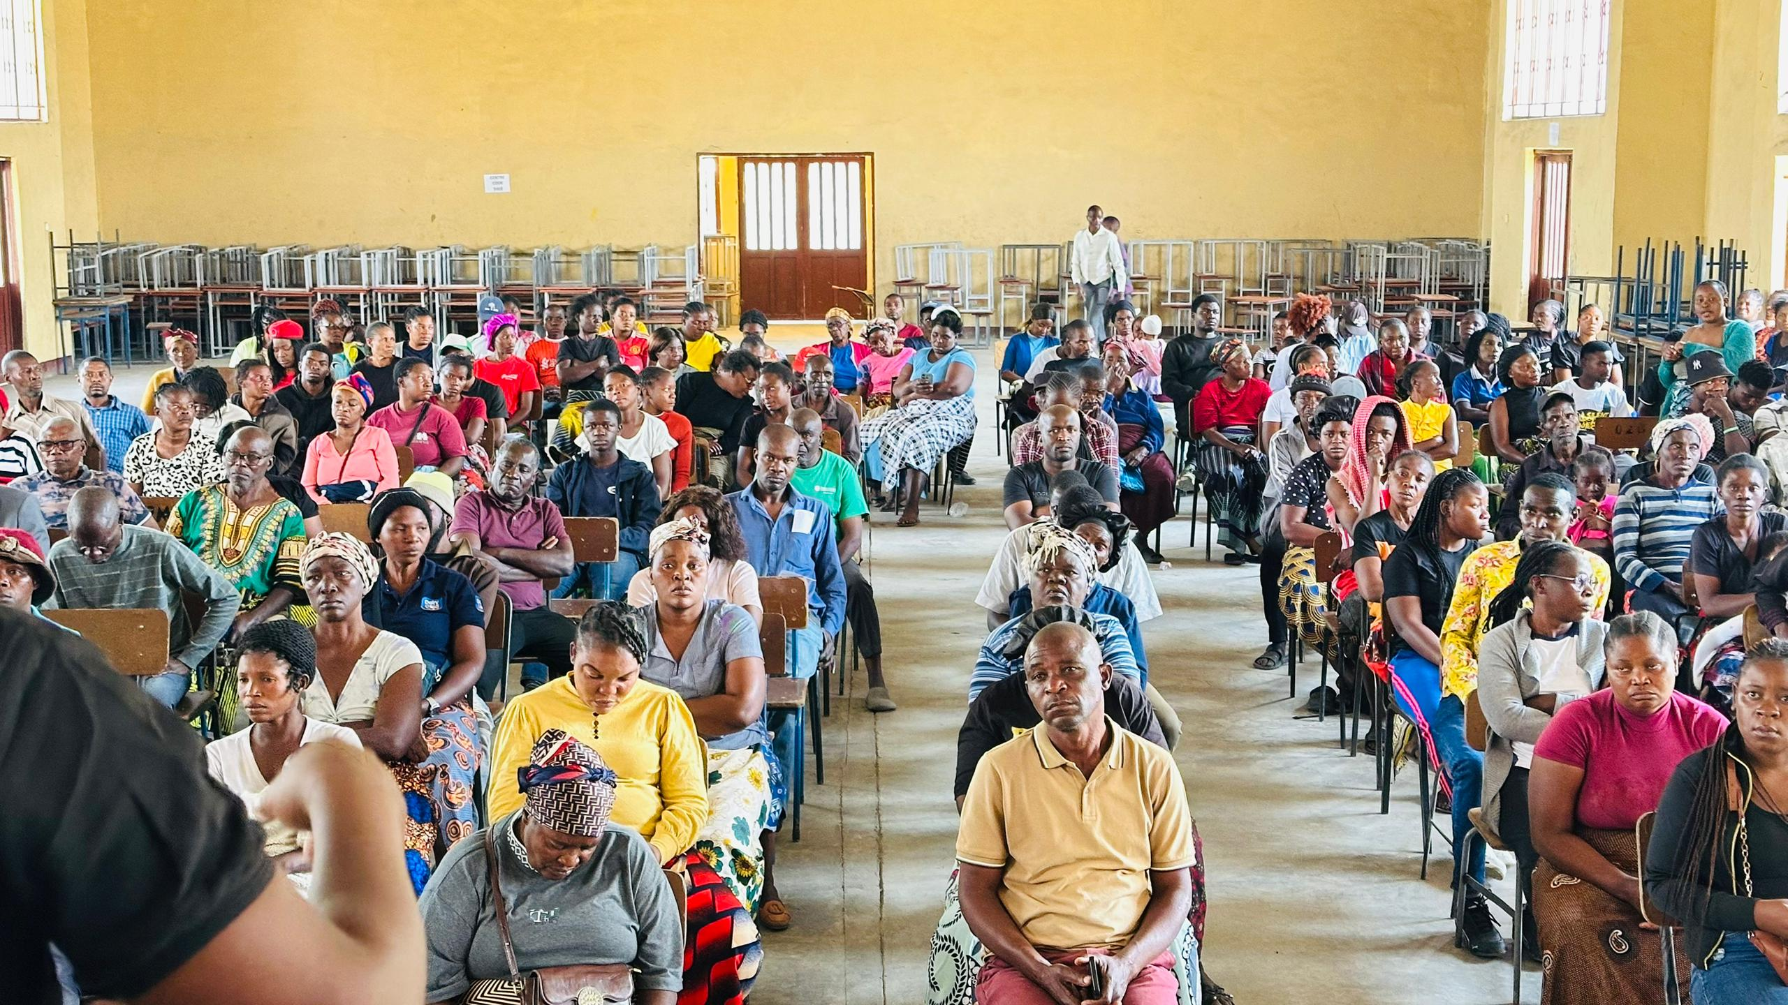
Chinika ward community members had members across all age groups.
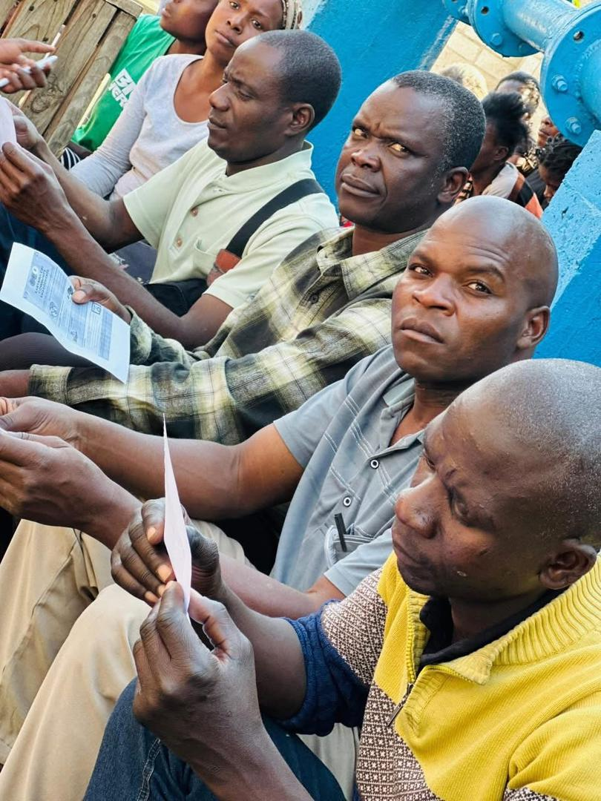
Kanyama ward 13 men turned up for the program.
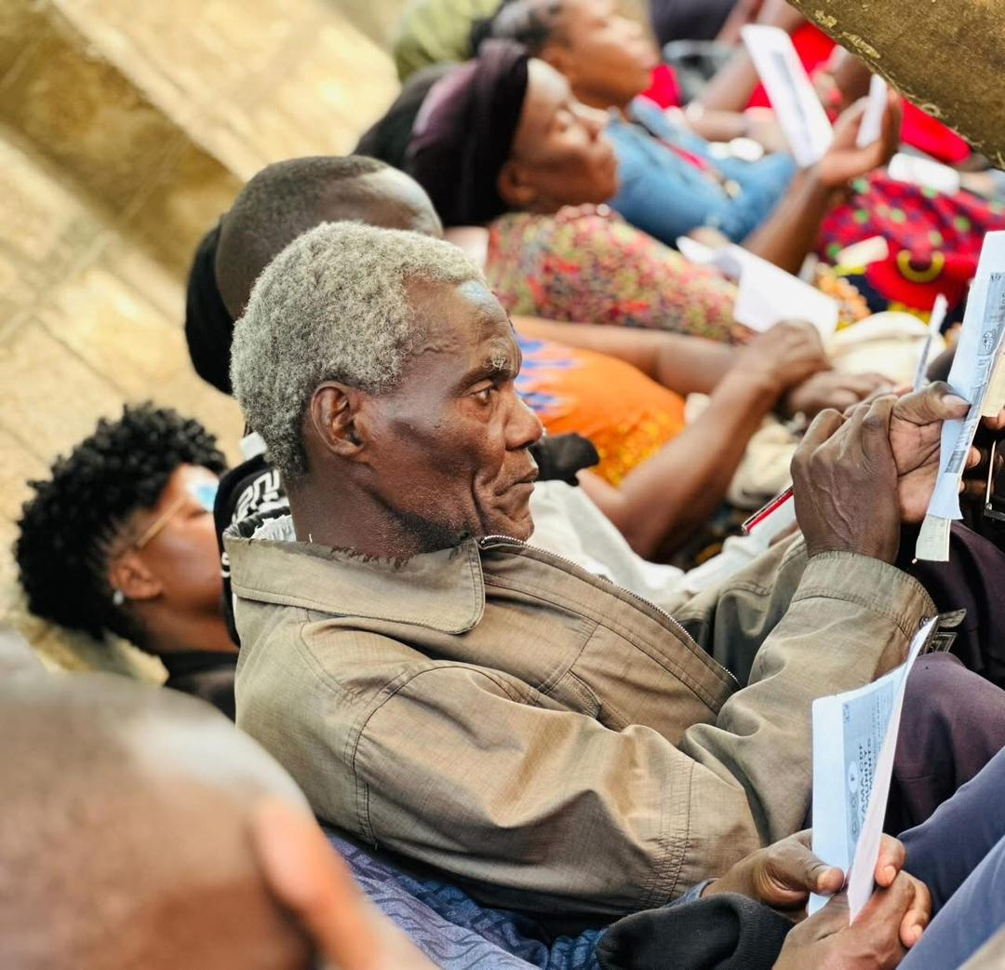
Kanyama ward 13 elderly community members were equally interested in learning more about CDF.
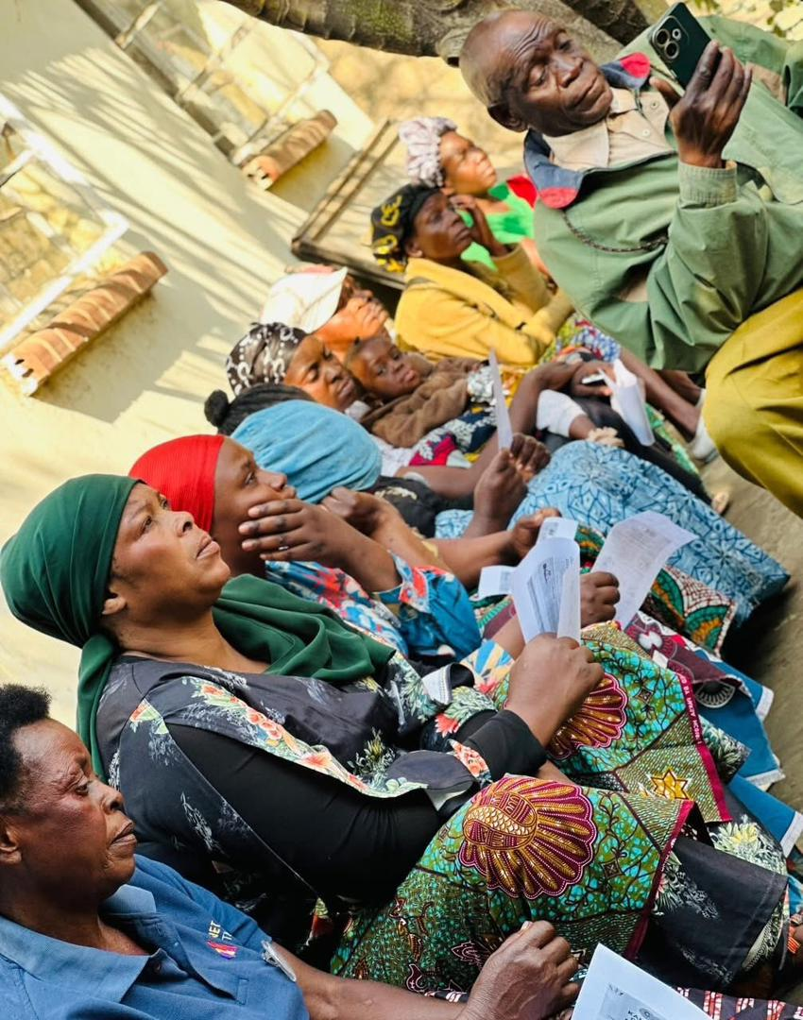
Kanyama ward 13 community members listening attentively.
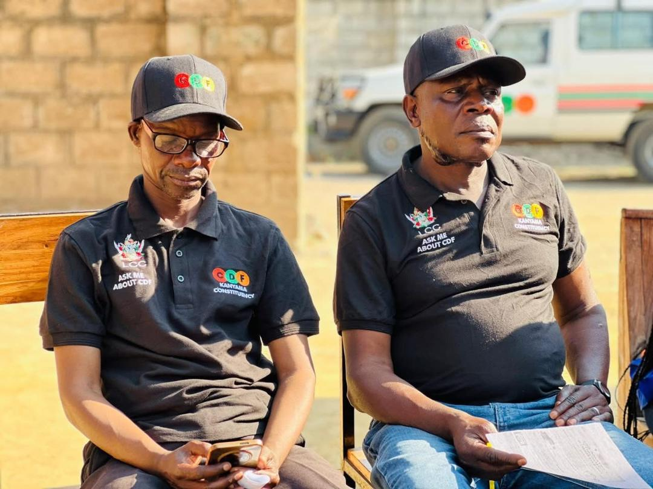
Kanyama ward 13 WDC members.
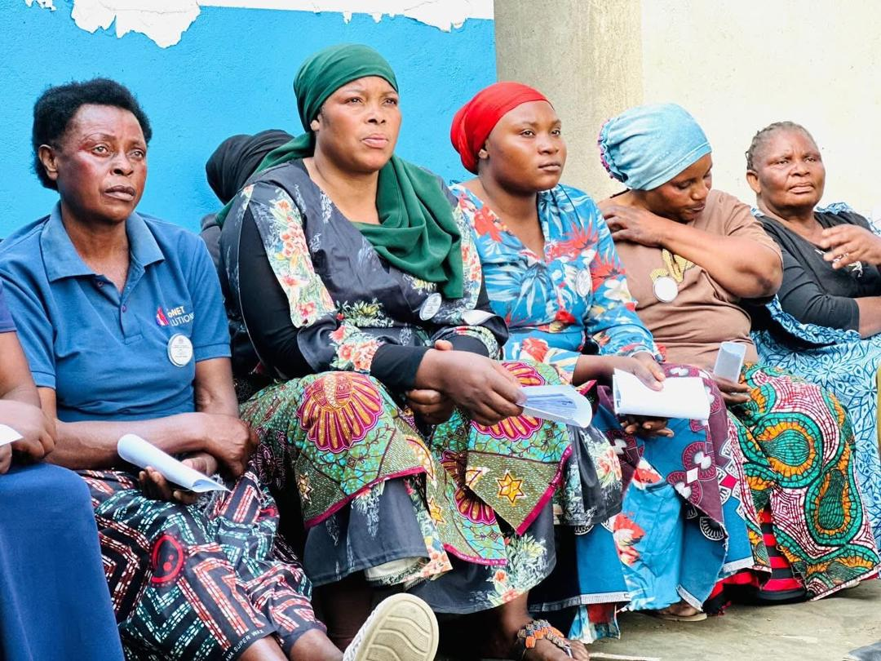
Kanyama ward 13 women turned up in great numbers.

