

LUSAKA CITY COUNCIL

REPORT ON COMMUNITY ENGAGEMENT PROGRAM LUSAKA CENTRAL CONSTITUENCY (2025)

CONSTITUENCY DEVELOPMENT FUND (CDF) COMMUNITY ENGAGEMENT MEETINGS IN KABULONGA, LUBWA, INDEPENDENCE AND SILWIZA

SUBJECT : Community Engagement Program
CONSTITUENCY : Lusaka Central
LOCATION : Kabulonga, Lubwa, Independence and Silwiza Ward

INTRODUCTION
CDF was introduced and approved by national Assembly in 1995 to facilitate the delivery of public goods and services to foster national development for local communities. The objective was to create an enabling environment for a holistic development at constituency level to implement projects which improve the wellbeing of the people in their constituencies.
The Scope of the CDF has expanded and its budgetary allocation increased to support Community-Centered Development, encourage entrepreneurship and promote access to education and skills development by orphaned and vulnerable community members.
The Lusaka Central Constituency community engagement team conducted a 10 days sensitization program in all the 4 ward under Lusaka Central Constituency.
The community engagement team comprised of the following officers:
SN | NAME | POSITION/DEPARTMENT
1. | Mcmillan Mandevu | Social Economic Planner
2. | Jumbe Zulu | Social Economic Planner
3. | Kabesya Lungu | Social Economic Planner
4. | Njumali Mollel | Ag. Social Economic Planner
5. | Mulawa Nkomesha | Ag. Social Economic Planner
6. | Kabaenda Makwela | Public Relations Officer
7. | Maliwa Pelekelo | Intern
8. | Nyuma Banda | Intern
9. | George Phiri | Driver
10 | Irine Muhongo | WDC Kabulonga Ward
11. | Mr. Akokwa | WDC Kabulonga Ward
12. | Sydney Chikwa | WDC Lubwa Ward
13. | Glory Muchanga | WDC Independence Ward
14. | Royce Sakala | WDC Independence Ward
15. | Samson Mbewe | WDC Silwiza Ward
16. | Brian Mwamba | WDC Silwiza Ward
17. | Marion Mapanza | WDC Silwiza Ward

The main objective of the community engagement program was to sensitize the community on CDF, the components of CDF and the process of CDF application process for all the 3 components from submission to implementation. Listed below are the outlined notes as presented to the community in all the 4 wards.
The Constituency Development Fund (CDF) has three (3) components namely:
  - Community Based Projects,
  - Youth, Women and Community Empowerment, and
  - Secondary Boarding School and Skills Development Bursaries.

SECONDARY BOARDING SCHOOL AND SKILLS DEVELOPMENT BURASARIES
The objectives of the bursaries are:
  - To enhance human development and drive the entrepreneurship agenda at the local level.
  - To provide for vulnerable learners to access Secondary Boarding Schools and Skills Training Institutions offering Technical Education, Vocational and Entrepreneurship Programs.
YOUTH, WOMEN AND COMMUNITY EMPOWERMENT
- Promotes apprenticeship, mentorship and business development services to support enterprise development and creation of market linkages.
- Equip beneficiaries with seed money in form of grants given to organized groups, clubs and cooperatives.
- Equip cooperative and individuals to establish small and medium scale business with empowerment loans.
COMMUNITY BASED PROJECTS
- Community Projects shall address challenges of inadequate infrastructure, such as: Water and Sanitation Points, Schools, Health Facilities, Police Posts, Feeder Roads, Market Shelters, Crossing Points, Canals and Dip Tanks etc.
- Project application forms shall be obtained from local authority, parliamentary constituency, WDC office and well as the local authority.
REQUIREMENTS FOR CDF COMPONENTS
SKILLS DEVELOPMENT BUSARIES

- Criteria and requirements for one to access skills development bursaries

SN | REQUIREMENTS
1 | Must be between 16 and 35 years of age
2 | Acceptance letter from a TEVETA Accredited Training Institution
3 | Recommendation letter from a clergy or civic leader
4 | Should be a Zambian with a Green National Registration Card
5 | Should be a residence of the particular constituency for more than 6 months
6 | Entrepreneurs that need up scaling and re skilling

SECONDARY BOARDING BURSARY

- Criteria and requirements for one to access secondary boarding bursaries

SN | REQUIREMENTS
1 | Should have an acceptance from a GRZ /Missionary boarding School
2 | Recommendation letter from a clergy or civic leader or Head of previous school
3 | Attach NRCs and contact information of Guardians
4 | Should be a residence of the particular constituency for more than 6 months

NB: Attach any of the following documents:-
- Death certificates/ burial permit of parents/guardian
- or letter from traditional leadership confirming the death of parents/ guardians
- or disability card or letter from the hospital

LOANS

- Criteria and requirements for one to access loans

SN | REQUIREMENTS
1 | Must have a registered company with PACRA/ Registrar of Societies
2 | Must have a viable business proposal (to be approved by the bank)
3 | Proof of Bank account suggested by the constituency
4 | The proposals should provide employment opportunities
5 | The proposed project must be undertaken within the particular constituency
6 | Should be a residence of the particular constituency for more than 6 months

GRANTS

- Criteria and requirements for one to access grants

SN | REQUIREMENTS
1 | Must have a registered club/organized group/cooperative registered with PACRA/ Registrar of Societies/Local Authority
2 | Must have a viable business proposal
3 | Should have minutes to prove that they sit as a club/cooperative time and again
4 | Should be a residence of the particular constituency for more than 6 months
5 | The proposed project must be undertaken within the particular constituency
6 | Proof of Bank account suggested by the constituency
7 | Must have a minimum of 10 members with valid Green NRCs

COMMUNITY PROJECTS

- Criteria and requirements for one to access community projects

SN | REQUIREMENTS
1 | The WDCs shall prepare meetings with the zonal leaders (the projects shall be in line with the Ward Development plan, IDP, any other Local Development Framework. In the absence of such plans, community needs shall inform the criteria for identification of projects.
2 | Any potential Bidders can visit the procurement office at civic center to be oriented on the use of the mandatory EGP (electronic government procurement) platform
3 | The proposed community project must be undertaken within the particular constituency

CONCLUSION
The community engagement meetings were a success and with the increase in the scope of CDF both financially and in terms of the volume of activities to be covered, it calls for increased capacity/awareness on the part of the CDFC and all stakeholders involved in the administration of CDF. There is also need for WDC offices in all the wards as this will enhance community engagement and accessibility of information on CDF from application to submission of all CDF components.
Find attached the pictures as captured by PR for all the community engagement meetings conducted in all the 4 wards.
Signed by:
Ronald Ngala Kabesya Lungu
DPO SEP

………………………………………………………… ………………………………….
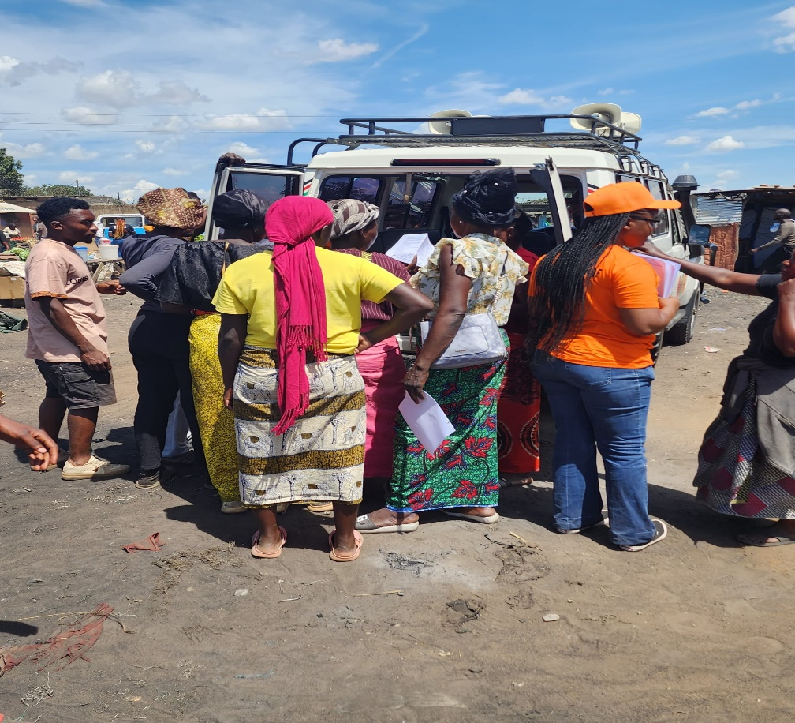*Kabulonga Ward

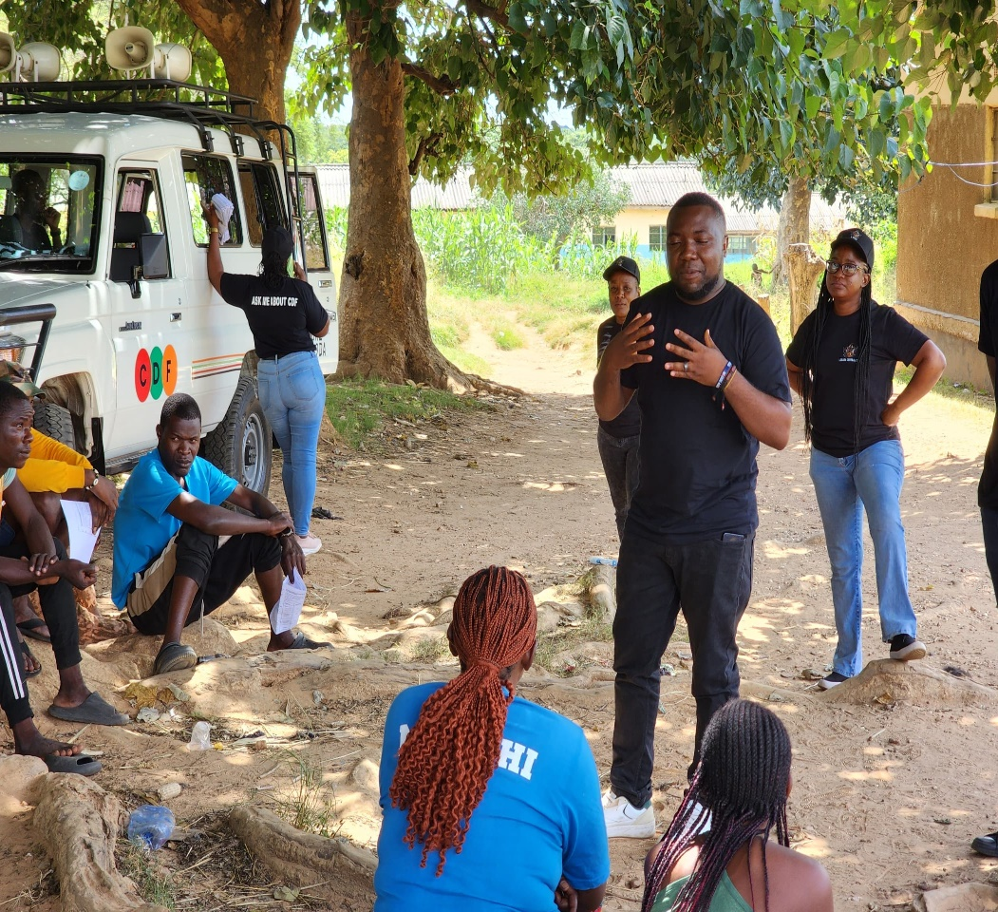*
Kabulonga Ward (State Lodge community engagement meeting)
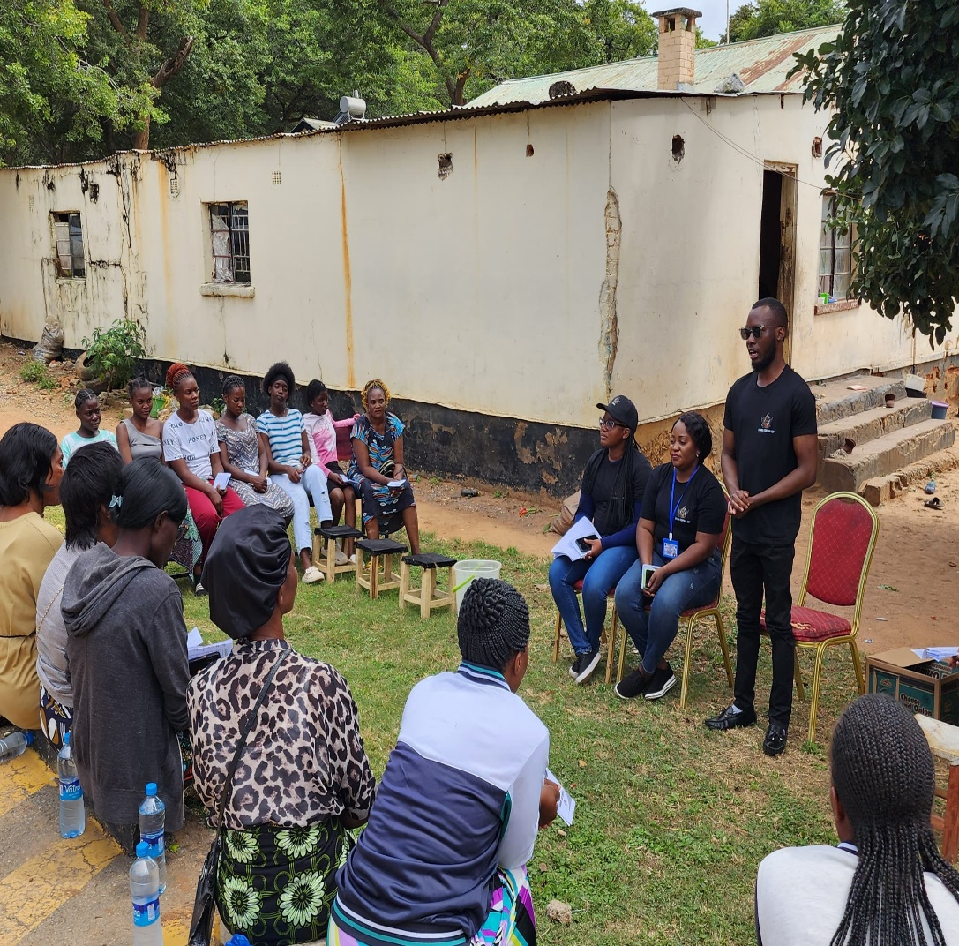
* Lubwa ward community engagement meeting
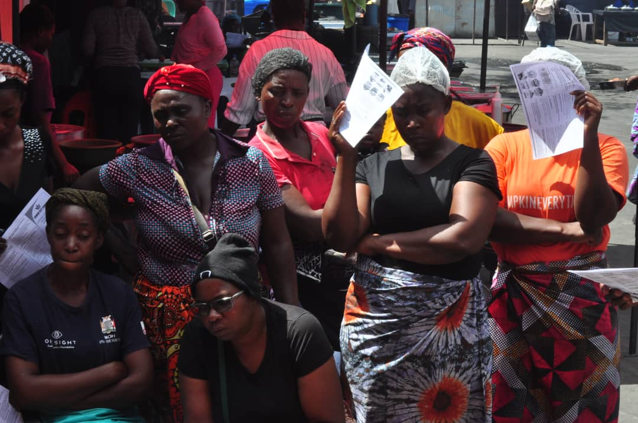* Lubwa Ward (UTH market)
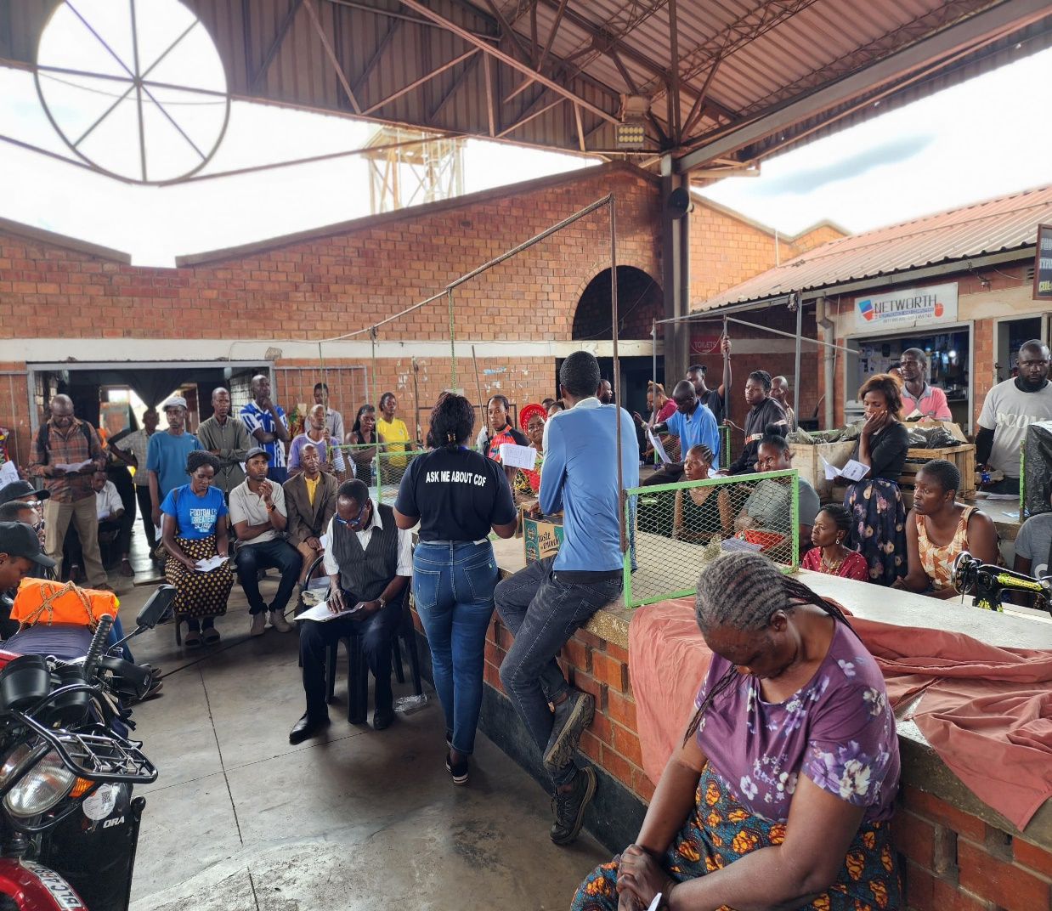* Lubwa Ward (Nyumba Yanga Market)
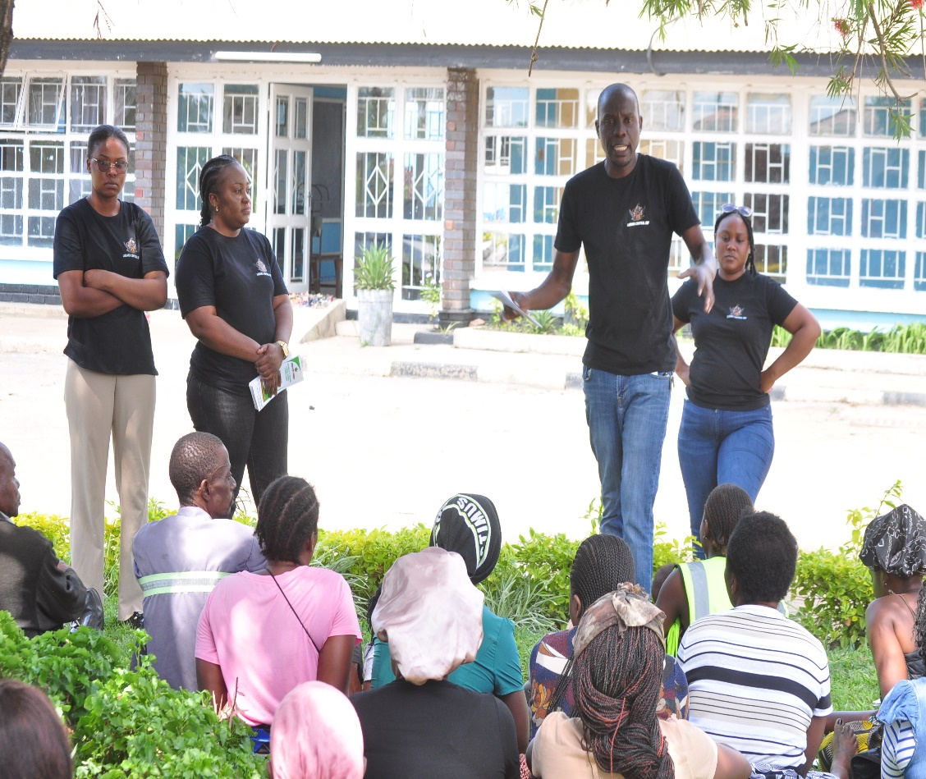* Silwiza Ward
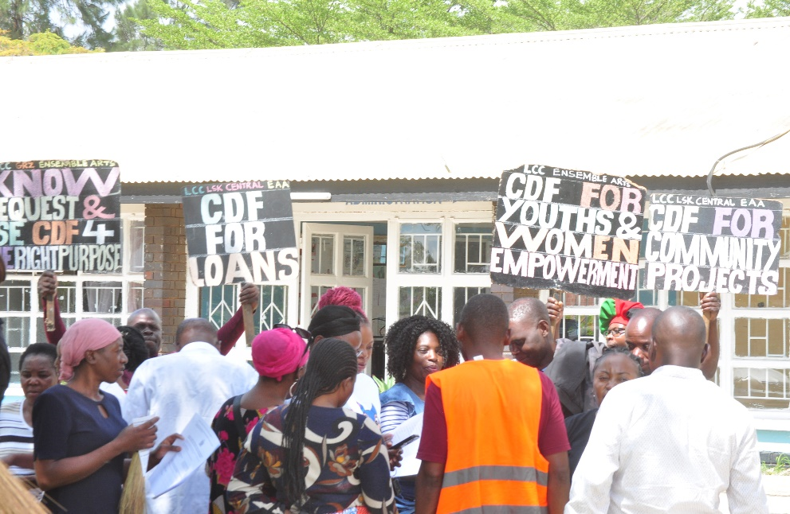

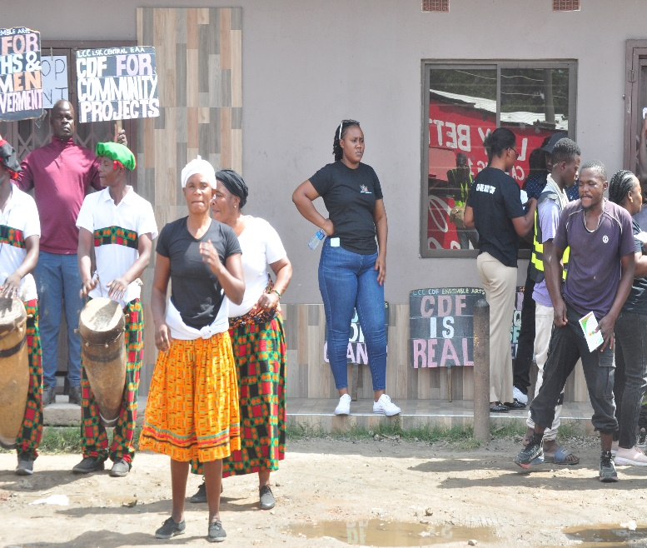
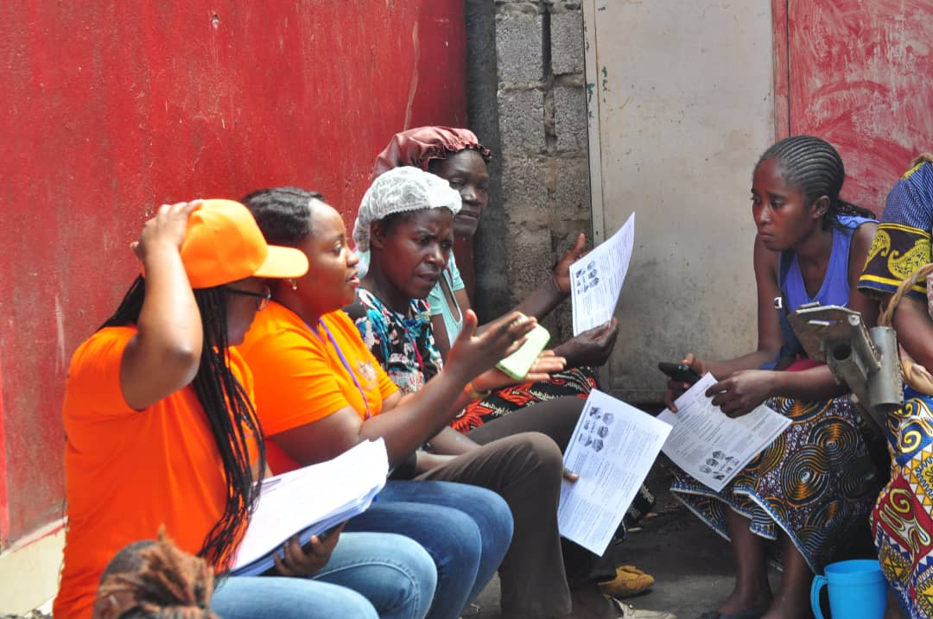
* Lubwa Ward
* Independence Ward
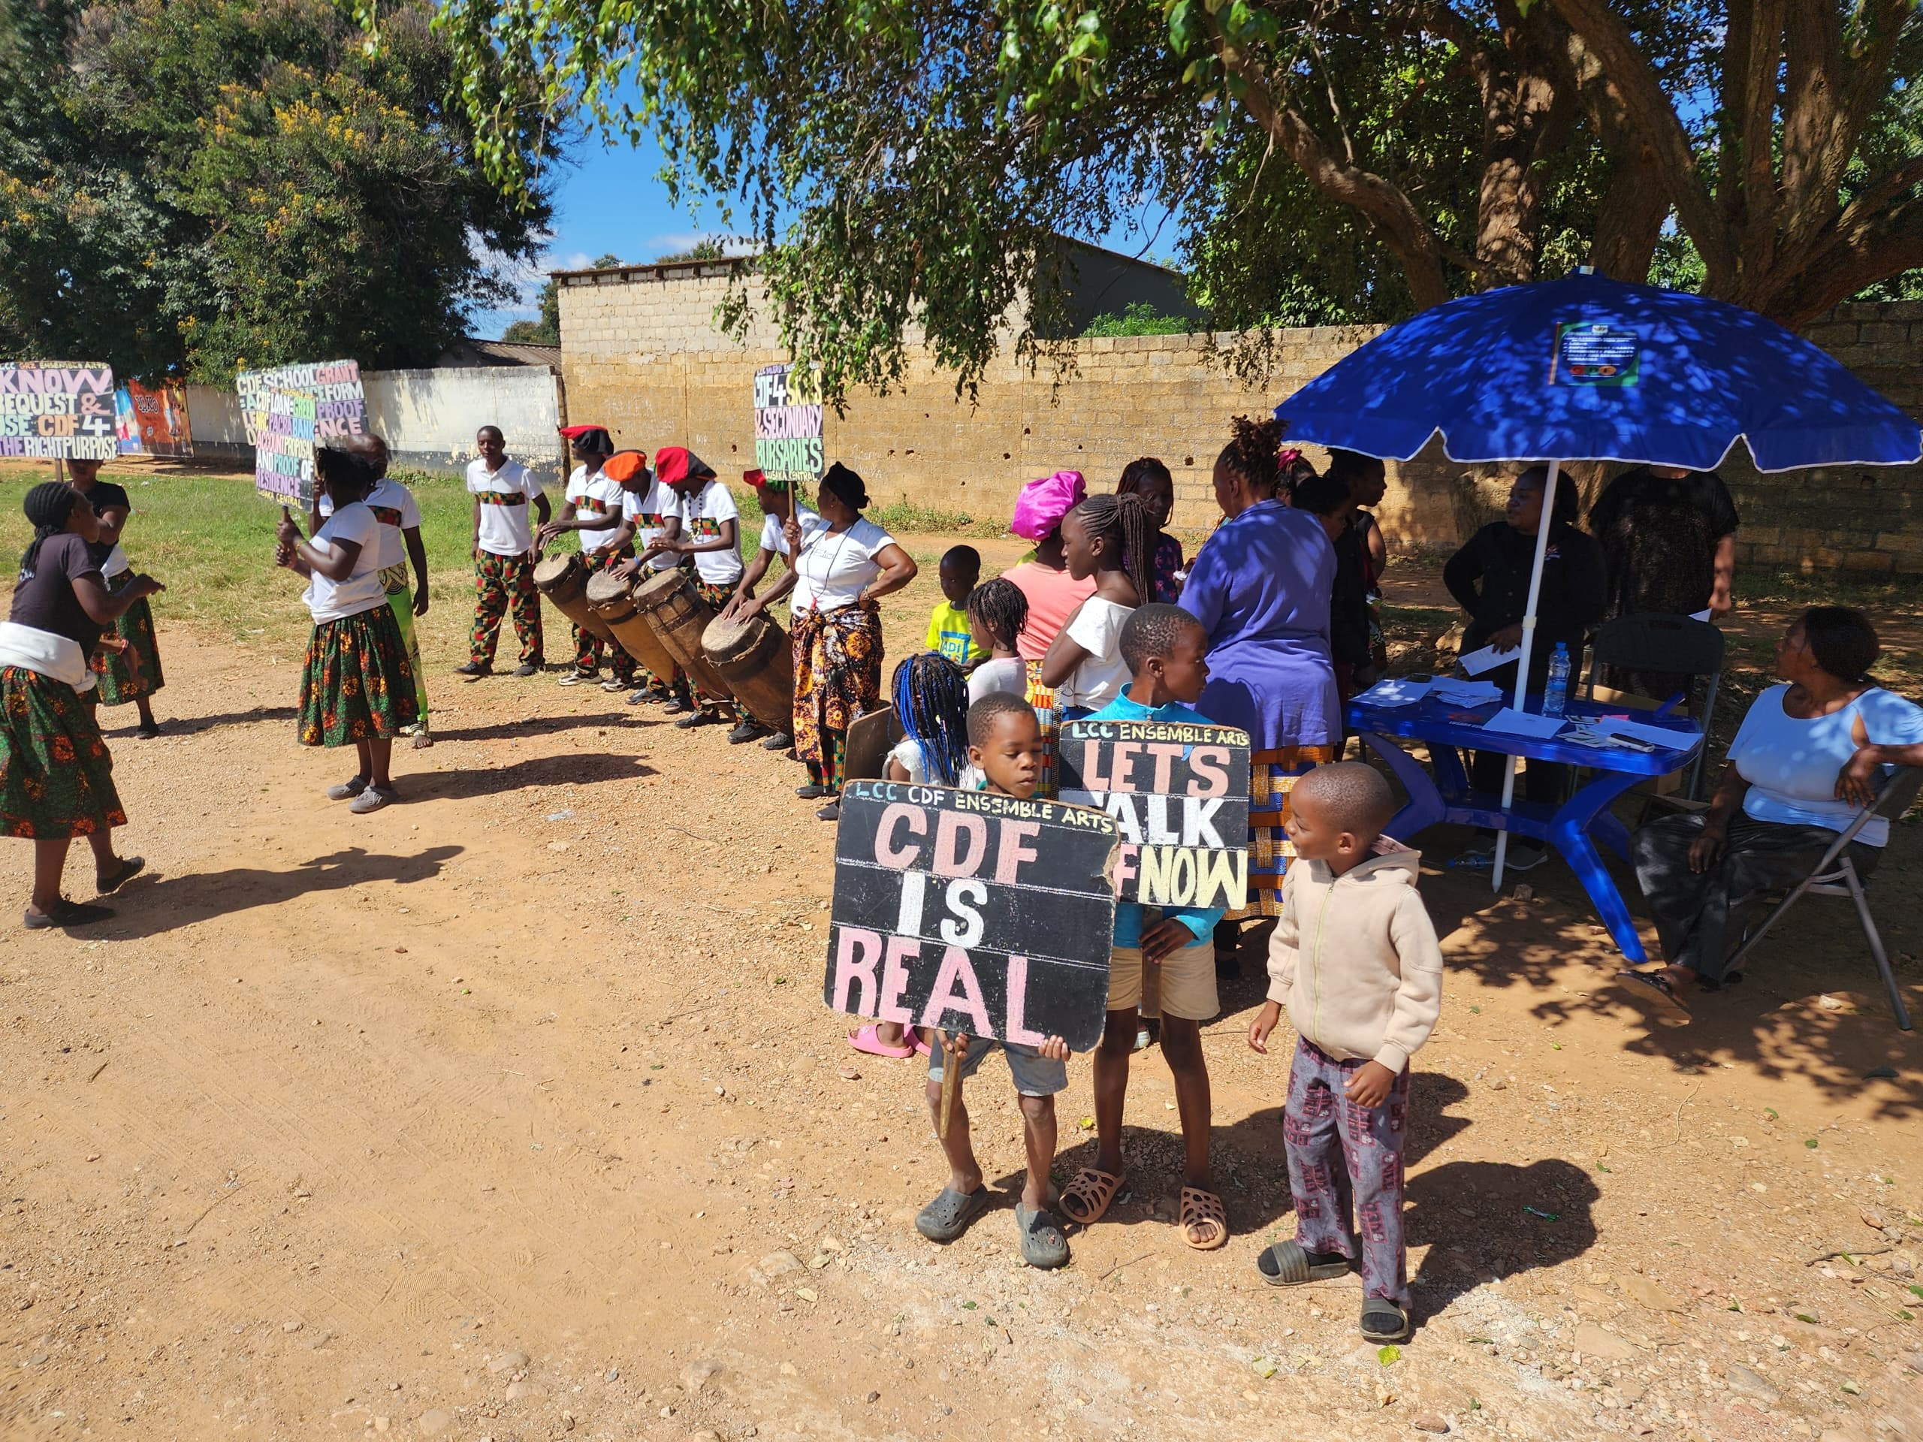
Independence Ward

