LUSAKA CITY COUNCIL
CITY PLANNING DEPARTMENT

Lusaka City Council

REPORT ON THE COMMUNITY SENSITIZATION CONDUCTED FROM 29TH MAY 2025 TO 20TH JUNE 2025 IN ALL THE SIX(6) WARDS OF MUNALI CONSTITUENCY.

INTRODUCTION
The government of the Republic of Zambia through the Ministry of Local Government, has started the implementation of various projects and youth women and community empowerment, through the Constituency Development Fund, which has seen many constituencies throughout the country benefiting in various ways. It is through this background that community engagement was carried out in Munali constituency, to ensure that communities are well informed and are aware of the benefits that can be actualized in the community at grass root level. Through the constituency development fund.
Munali Constituency which has six wards in total has a number of diverse communities, a variety of businesses and also has a number of unplanned settlements with various levels of income and livelihood ,which enabled the officers to interact with people in various wards of the constituency.
The Sensitization was conducted in all the wards of the constituency namely, Chakunkula, Chainda, Kalikiliki, Mtendere, Munali and Kalingalinga ward. The program begun in Chainda ward on the 29th of May 2025 and concluded on 20th June 2025 in Munali ward, which marked the close of the sensitization.

OBJECTIVES OF THE PROGRAM
Community sensitization is a prerequisite for better understanding of CDF programs. It is effective in bringing awareness in the communities and bridge the information gap in settlements.
The objectives included
- To make communities aware and motivated about CDF programs.
- Encourage the communities to be involved actively in implementation, selection and management of CDF programs at grass root level.
- Inform the communities about the application process of CDF components and also guide on application procedure.

PROGRESSION OF PROGRAM
The various wards in Munali, located in the eastern side of Lusaka, has a good number of settlements classified as unplanned and as such the settlements have many challenges including unemployment, early marriages, high poverty levels, lack of proper water and sanitation services and lack of education of many of the youths in the settlements.
The population of the settlement is approximately twenty six thousand, and most households are into sale of daily household goods.
The community engagement in Chainda took place on 29th May 2025 at the UNIP market near the WDC office. The Lusaka city council officers sensitized to the residents about the various components of Constituency Development Fund and the requirements for individuals to be able to access the various respective components i.e. community projects, empowerment loans and grants and skills development bursaries.
The engagement with the community was a success in that it gave an opportunity for the residents to interact with the officers, participation of the Ward development committee, a good number of residents came out to interact with the officers on the ground ,and they asked many questions and looked optimistic to try and apply for the different components under CDF.

Below were the frequently asked questions, and photo illustration of officers interacting with community members:
FAQ
- What is the mode of application?
- Sponsorship of over-aged?
- How long does it take to receive the loan funds?
- What is the maximum amount for loans grants?

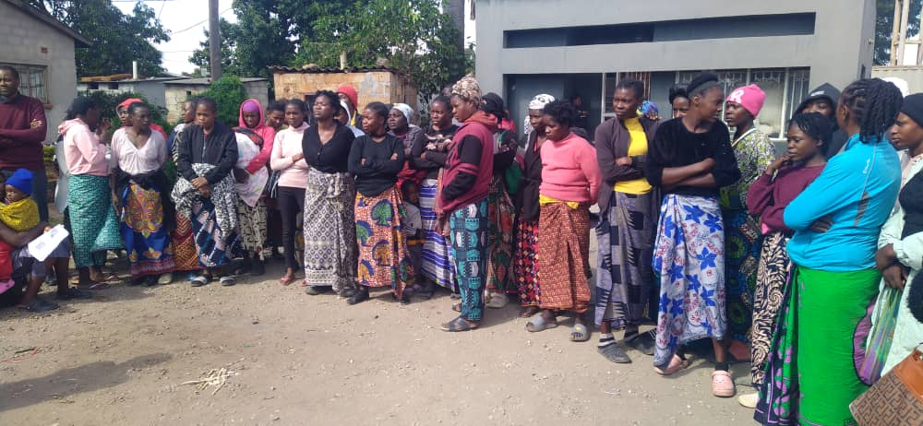
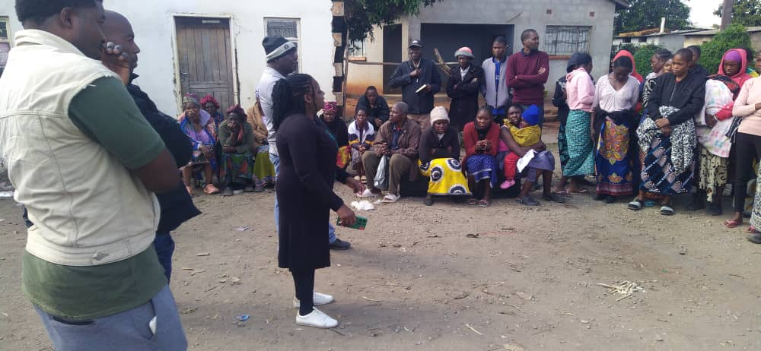

The second part of the sensitization was done in Kalingalinga ward, on 10th June 2025 at the Kalingalinga community center, with the participation of the Ward Development Committee.
A good number of residents came out to interact with the officers on the ground and they asked many questions and looked optimistic to try and apply for the different components under CDF.
In this ward the community engagement was done at the kalingalinga community center where the officers interacted with community members.
In the third part of the sensitization was done in Kalikiliki, Mtendere and Munali wards, where a drama group was engaged to ensure the community was entertained while they received information on as most of the time drama and music leave a lasting impression on individuals.

Below are pictures that show officers engaging with the community and the drama group engaged to disseminate information.

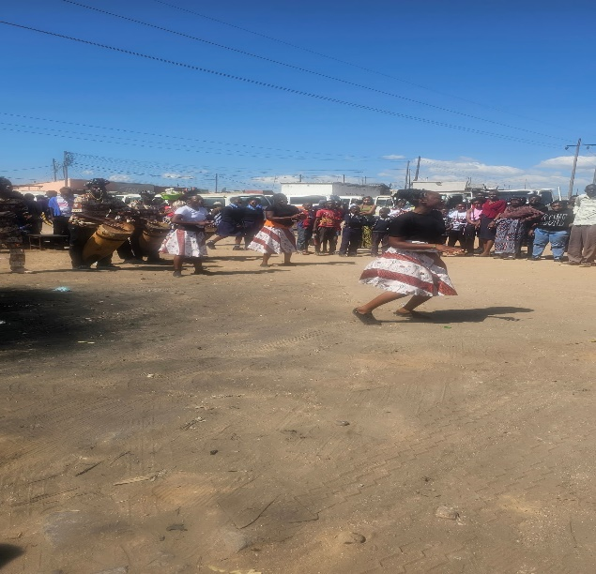
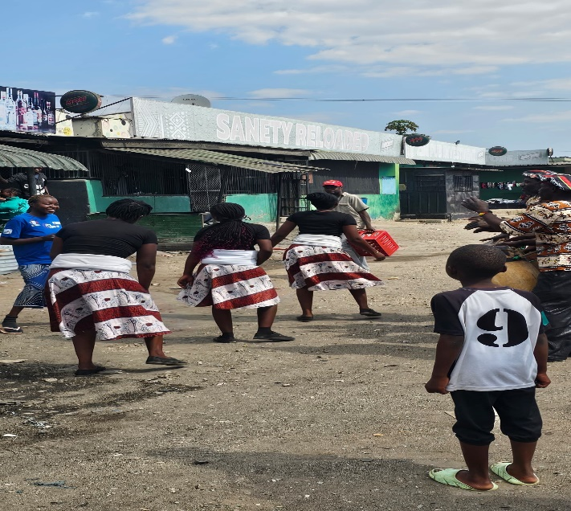

Sensitization being conducted in kalikiliki ward.
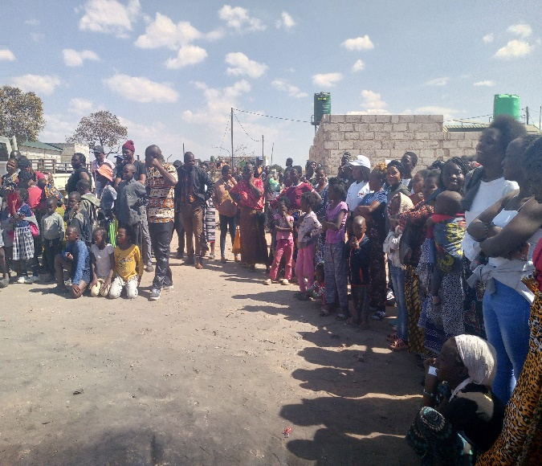
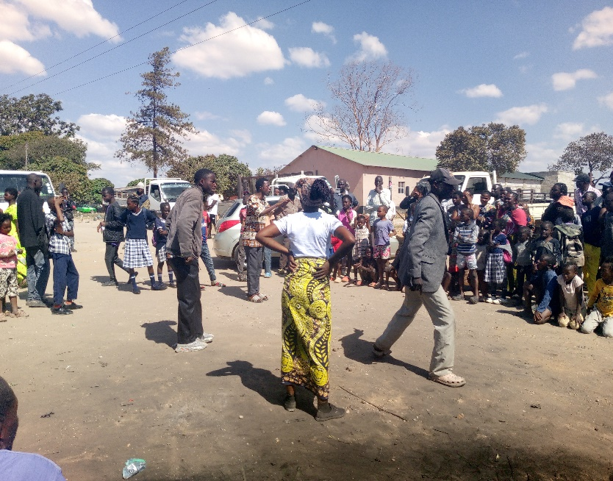
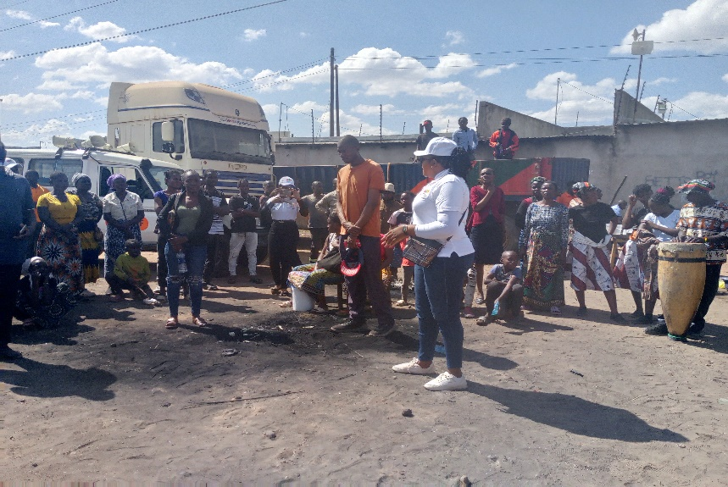
Social economic planner answering some questions during the sensitization.

CONCLUSION
In conclusion, sensitization of the communities visited on the constituency development fund was successfully done in all the six wards of the constituency.
The program was necessary as it made residents aware of the different components under CDF and gave them a platform to engage with the officers from the local authority, this in turn made them enthusiastic and eager to know more about the processes involved in applying for the various components under CDF and many of the residents were eager to visit the WDC offices and council offices in order to gain more knowledge on CDF application

PREPARED BY CHECKED BY
Carol Kalebwe Ronald Ngala
Socio economic planner District Planning Officer

