LUSAKA CITY COUNCIL
OFFICE OF THE DIRECTOR CITY PLANNING

REPORT ON COMMUNITY ENGAGEMENT IN MANDEVU CONSTITUENCY
Dates: 22nd April – 2nd May, 2025
Introduction
The Constituency Development Fund (CDF) is established under Article 162 of the Constitution of Zambia, Act No. 2 of 2016, and operationalized by the Constituency Development Fund Act No. 11 of 2018. The Act provides for the management, utilization, and accountability of the CDF.
In line with these provisions, it is imperative that prior to the opening of applications each year, comprehensive sensitization and education is undertaken through structured community engagements. Accordingly, from 22nd April 2025 to 2nd May 2025, the Constituency Office conducted community engagement activities across Mandevu Constituency.
The key objective was to sensitize residents on the 2026 CDF empowerment opportunities covering Community Projects, Youth and Women Empowerment (Loans and Grants), Skills Development, And Secondary School Bursaries.

Main Body
Method of Engagement
To enhance participation and understanding, a drama group was engaged to deliver interactive performances highlighting the benefits and processes of the CDF components. This approach proved highly effective in attracting large numbers of community members and encouraging dialogue.
Community Projects
Residents were educated on developing project proposals aimed at addressing local challenges, particularly in infrastructure such as feeder roads, schools, health facilities, water, and sanitation.
Loans and Grants
The community was sensitized on opportunities for entrepreneurship and economic empowerment through CDF-funded loans and grants, with emphasis on promoting mentorship, apprenticeship, and business growth.
Skills Development and Secondary Boarding School Bursaries
Awareness was raised on the availability of bursaries to support vulnerable learners at secondary school level as well as for skills training programmes, thereby contributing to human capital development within the constituency.
Conclusion
The community engagement activities in Mandevu Constituency were successfully conducted within the stipulated period. The innovative use of drama performances significantly boosted attendance and understanding of CDF processes. The overall response was positive, and the sensitization achieved its intended purpose of preparing community members for active participation in the 2026 CDF empowerment cycle.

Recommendations
- Future engagements should continue to employ interactive and innovative methods such as drama to maximize impact.
- Increased funding under CDF is recommended to cater for the growing demand across all components.
- Continuous follow-up and monitoring mechanisms should be strengthened to ensure that beneficiaries fully utilize the opportunities availed.
Supporting photographs attached.

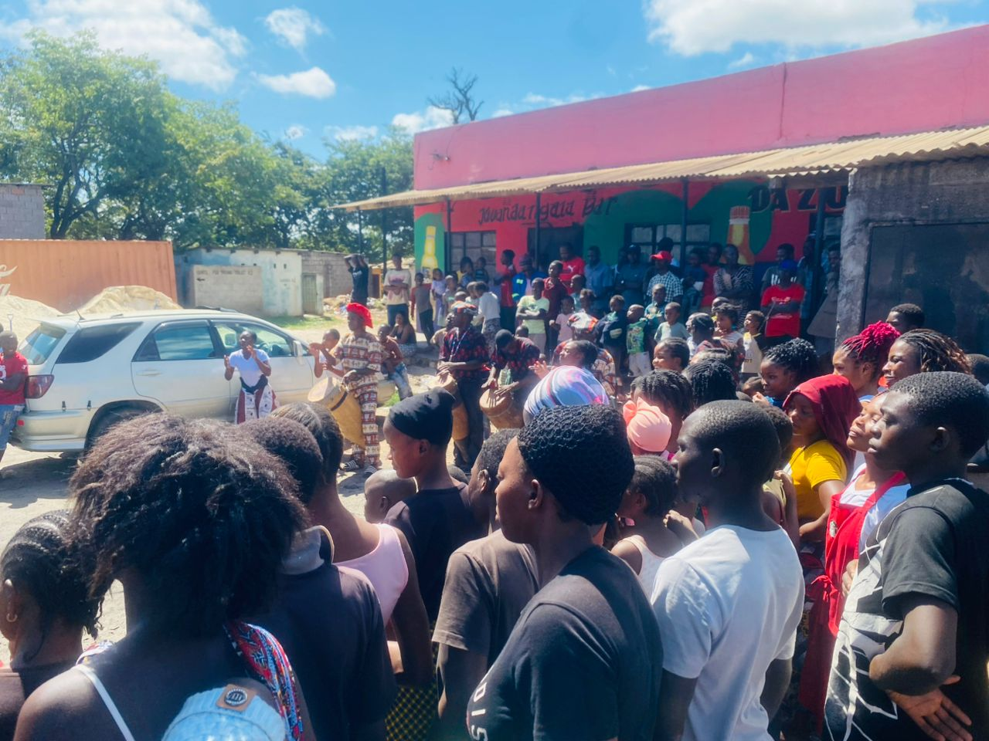
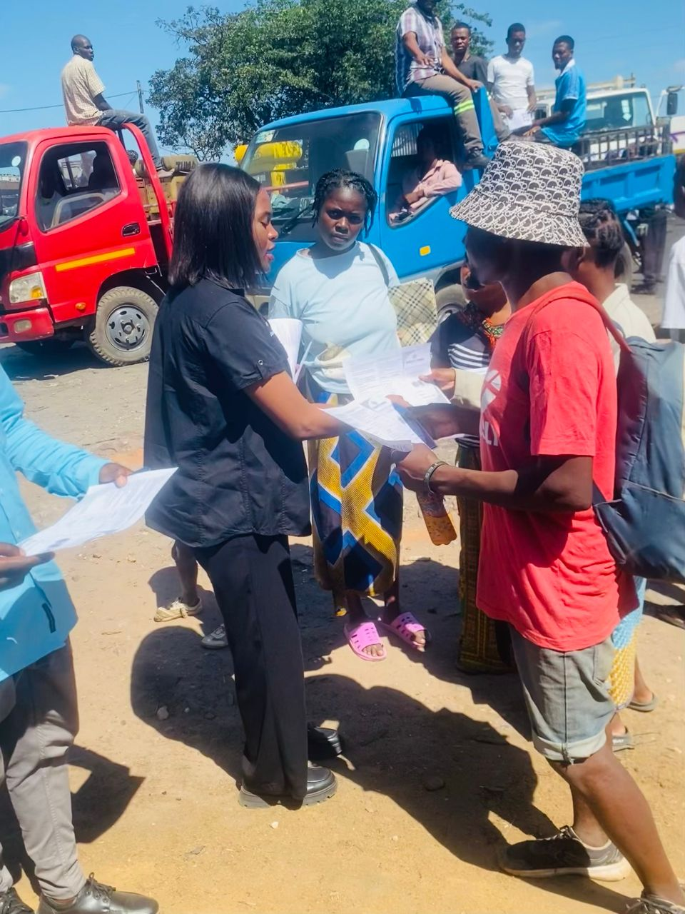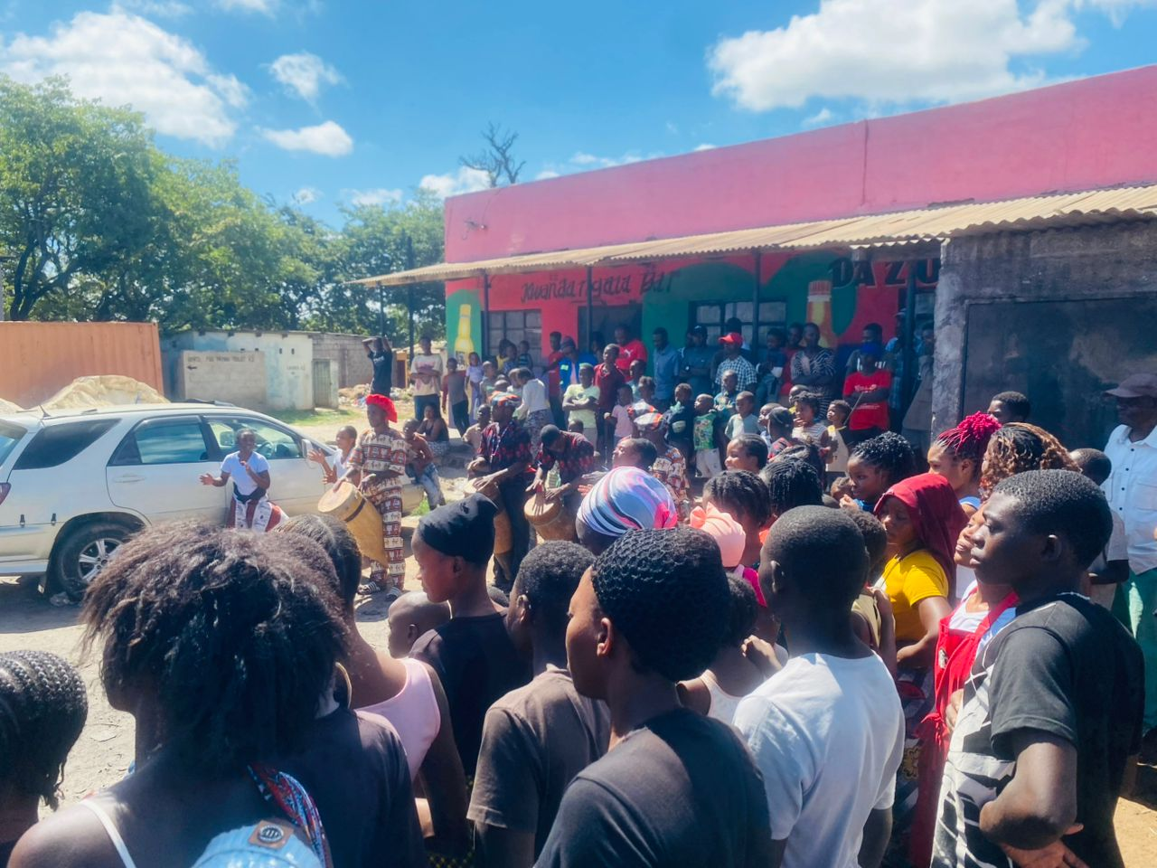
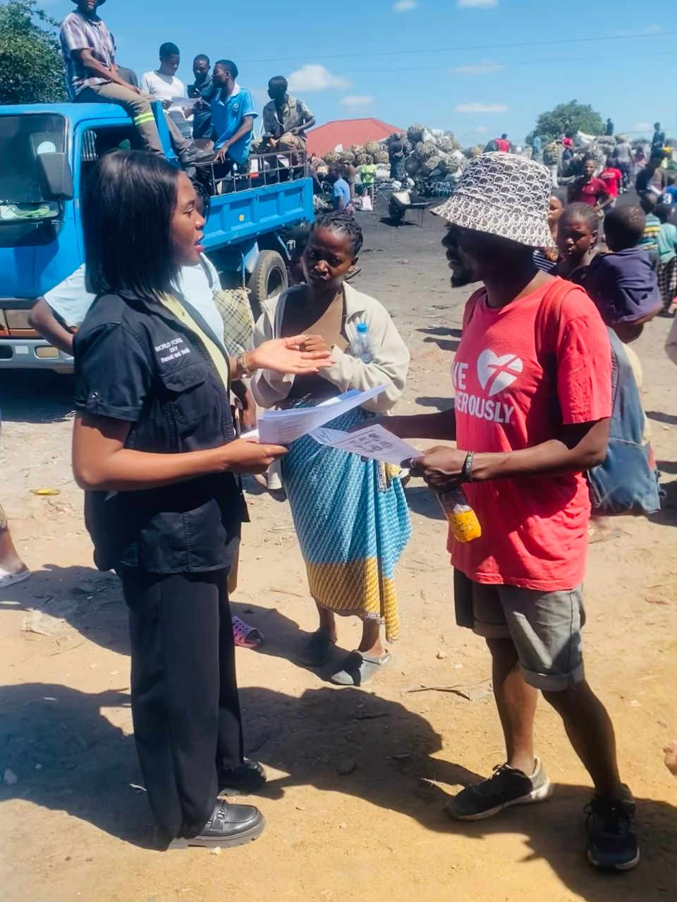

PREPARED BY: ______________________________________
DATE: ______________________________________
CHECKED BY: ______________________________________
DATE: ______________________________________

