LUSAKA CITY COUNCIL
REPORT ON THE SENSITISATION OF CDF COMPONENT IN CHAWAMA CONSTITUENCY FROM 26th MAY TO 6TH JUNE, 2025.

1.0 INTRODUCTION
This report covers the activities undertaken during the sensitisation of the community on how to access CDF for the three component which are Community Projects, Empowerments (Grants and Loans), Skills and secondary boarding Bursaries
1.1 OBJECTIVE
The objective of this activity was to sensitise the members of the public in all the 4 wards in Chawama Constituency on accessing the CDF in order to actualise implementation of Fiscal Decentralisation in line with the provisions of the Republican Constitution (Amendment) Act No. 2 of 2016 on Decentralisation and to support community level projects and other related community initiatives
The following officers attended the sensitisation meeting

- Felistus Hayumbu- Socio Economic Planner
- Catherine Chafunga- Socio Economic Planner
- Mendai Litempo– Community Development Officer
- Doris Musonda- Intern
- Alice Tembo- Intern

The key notes to the sensitisation are as stated below according to CDF components
SKILLS DEVELOPMENT BUSARIES
- Criteria and requirements for one to access skills development bursaries
SN | REQUIREMENTS
1 | Must be between 15 and 35 years of age
2 | Acceptance letter from a TEVETA Accredited Training Institution
3 | Recommendation letter from a clergy or civic leader
4 | Should be a Zambian with a Green National Registration Card
5 | Should be a residence of the particular constituency for more than 6 months
6 | Entrepreneurs that need up scaling and re skilling

SECONDARY BOARDING BURSARY
- Criteria and requirements for one to access secondary boarding bursaries
SN | REQUIREMENTS
1 | Should have an acceptance from a GRZ /Missionary boarding School
2 | Recommendation letter from a clergy or civic leader or Head of previous school
3 | Attach NRCs and contact information of Guardians
4 | Should be a residence of the particular constituency for more than 6 months

NB: Attach any of the following documents: -
- Death certificates/ burial permit of parents/guardian
- or letter from traditional leadership confirming the death of parents/ guardians
- or disability card or letter from the hospital

LOANS
- Criteria and requirements for one to access loans
SN | REQUIREMENTS
1 | Must have a registered company with PACRA/ Registrar of Societies
2 | Must have a viable business proposal (to be approved by the bank)
3 | Proof of Bank account suggested by the constituency
4 | The proposals should provide employment opportunities
5 | The proposed project must be undertaken within the particular constituency
6 | Should be a residence of the particular constituency for more than 6 months

GRANTS
- Criteria and requirements for one to access grants
SN | REQUIREMENTS
1 | Must have a registered club/organized group/cooperative registered with PACRA/ Registrar of Societies/Local Authority
2 | Must have a viable business proposal
3 | Should have minutes to prove that they sit as a club/cooperative time and again
4 | Should be a residence of the particular constituency for more than 6 months
5 | The proposed project must be undertaken within the particular constituency
6 | Proof of Bank account suggested by the constituency
7 | Must have a minimum of 10 members with valid Green NRCs

SUCCESS
The community engagement was a successful as members of the community responded very well and attended the meetings and they asked a lot questions about CDF. The availability of CDF monitoring vehicle made it easy to make announcements.
CHALLENGES
The period for community engagement was limited as it was done for a few days. Members of the community, upon hearing that the meeting did not attract any allowance.
Mobilizing people to come for meetings is a challenge because the sensitization normally takes place during working hours and most people are involved in different economic activities.

2.0 RECOMMENDATION
- The sensitisation meeting to be done more frequently in order for the community to be fully understand the CDF guidelines.
- There is need for established Offices for WDC to continue engaging with communities as they are they eyes of the Local Authorities on the ground
- There is need for a continuous robust community engagement on CDF using different media platforms such Radio, community meetings in different zones, flyers.
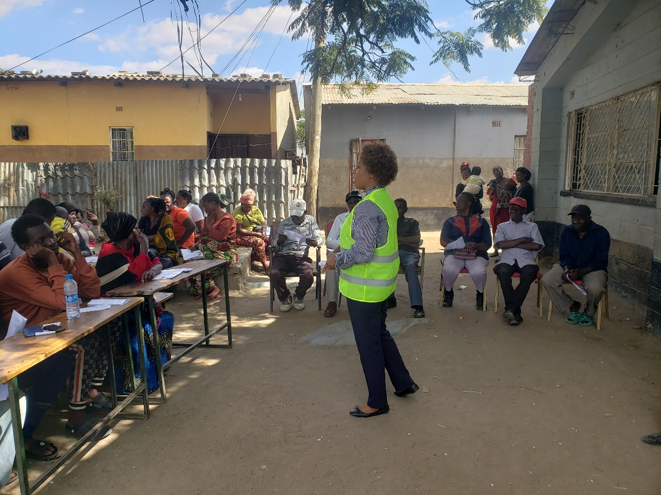
JOHN HOWARD WARD
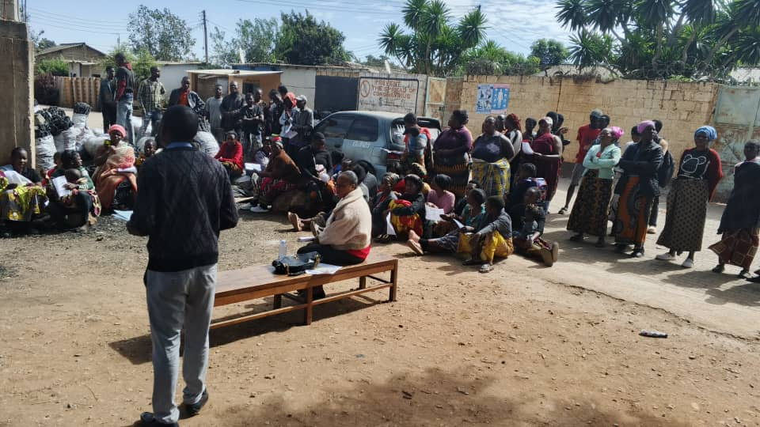

NKOLOMA WARD 1
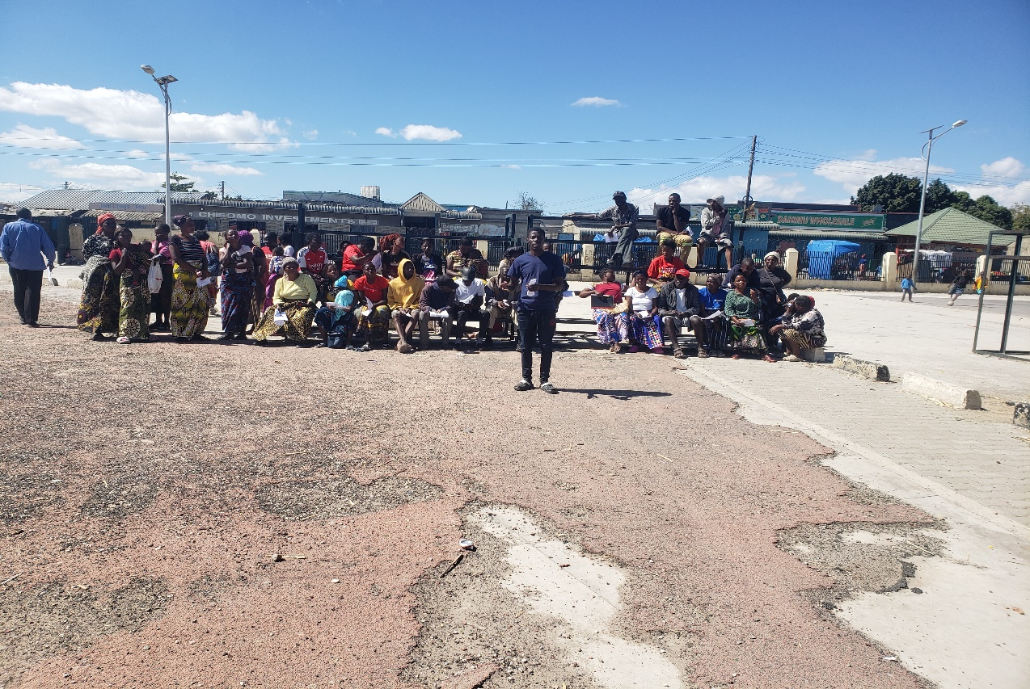

LILAYI WARD 4
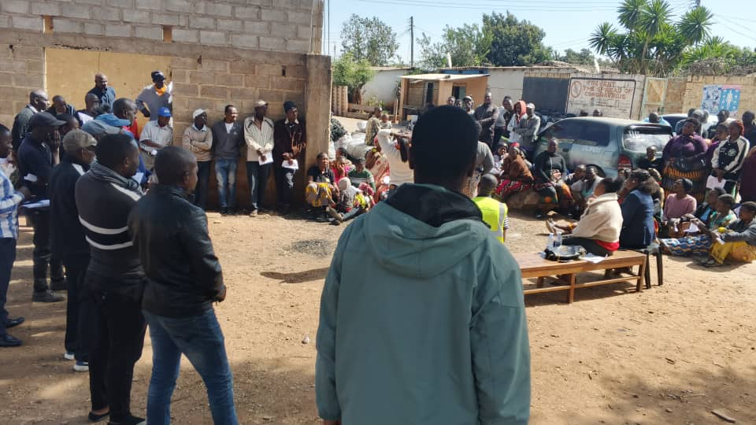

CHAWAMA WARD 2
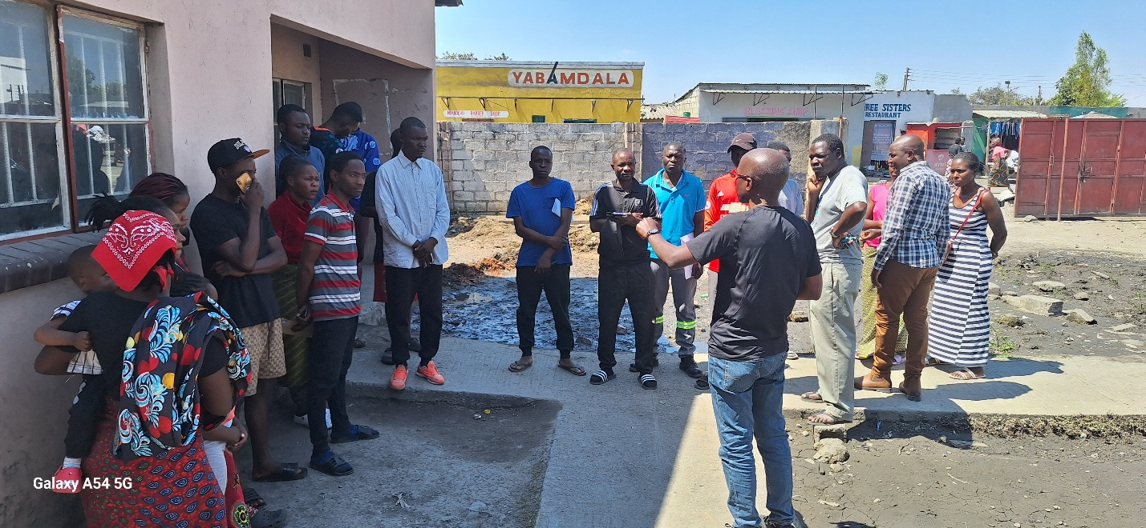
NYERERE COMMUNITY HALL

3.0 CONCLUSION
The calls for increased capacity on the part of WDC, CDFC and all the stakeholders’ involved in the administration of CDF to be actualised.
Report Prepared by
Felistus Hayumbu
Socio Economic Planner
SIGN……………

