LUSAKA CITY PLANNING
DISTRICT PLANNING UNIT

Community sensitization report on constituency development funds for the month of March, 2025.
Executive summary
This report outlines the findings and outcomes of a community sensitization programme on constituency development funds (CDF) which ran from 9th to 30th March, 2025. We did announcement and meetings. The programme aimed to educate citizens on the purpose, management, and benefits of CDF, promoting transparency, accountability, and community participation.
Programme outline
S/N | DATES | DETAILS | AREA
01 | 09- 10 March, 2025 | Announcements | Kamwala
 | 13- 14 March, 2025 | Meetings | Kamwala
02 | 15- 16 March, 2025 | Announcements | Kabwata
 | 17- 20 March, 2025 | Meetings | Kabwata
03 | 21- 22 March, 2025 | Announcements | Libala
 | 23- 24 March, 2025 | Meetings | Libala
04 | 27- 28 March, 2025 | Announcements | Chilenje
 | 29- 30 March, 2025 | Meetings | Chilenje

Introduction
Constituency development funds (CDF) are allocations of public funds designated for development projects within constituencies. Effective management and utilization of CDF require active participation and oversight.
Objective
- To educate community on the concept, purpose, and management of CDF.
- To promote transparency and accountability in CDF utilization.
- To encourage community participation in CDF project identification, implementation, and monitoring.

Methodology
- Community meetings
We had organized public meetings in selected communities to sensitize communities on CDF components such as “school bursaries, skills bursaries, grants, cdf loans and community projects.” How the youths, men and women can assess components mentioned above.
- Focus Group Discussions
Group discussions were conducted with community leaders, youth, and women’s groups. The community members who had attended were subjected into sitting in small discussion groups in order to make each member express themselves freely and ask questions where they were not satisfied.
- Information materials
We had distributed informational posters and constituency development fund application forms. The idea was to make the community have a feel of the forms and get to know how to effectively fill the forms.

Pictures of the communities we had visited
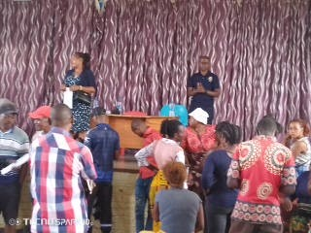
CHILENJE COMMUNITY HALL IN CHILENJE WARD
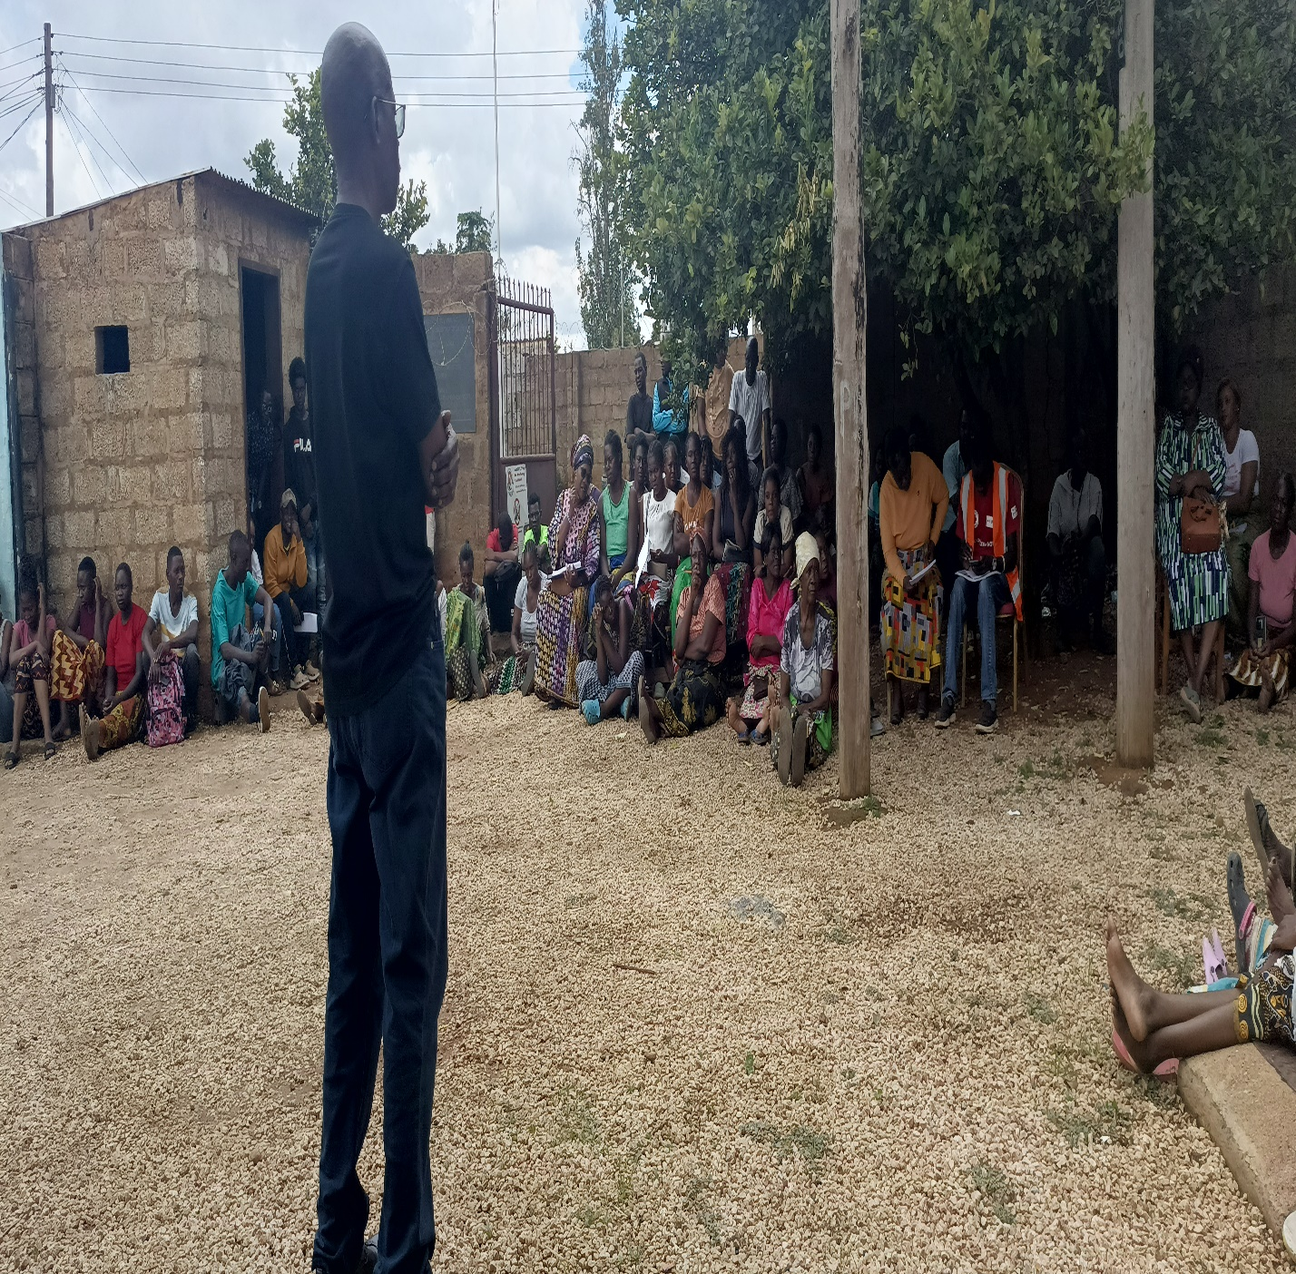
KAMULANGA WARD

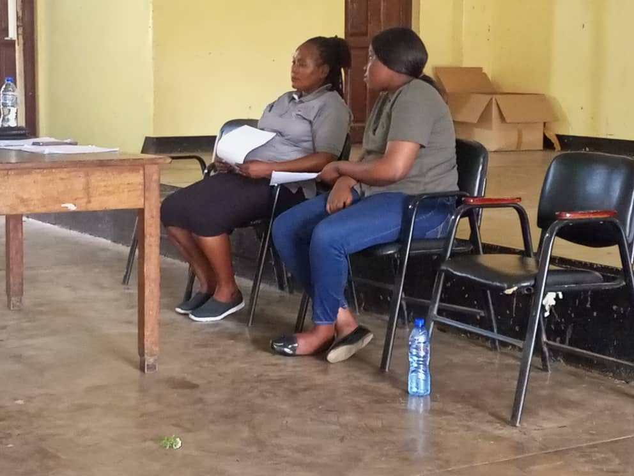
FACILITATORS AT LIBALA SECONDARY SCHOOL
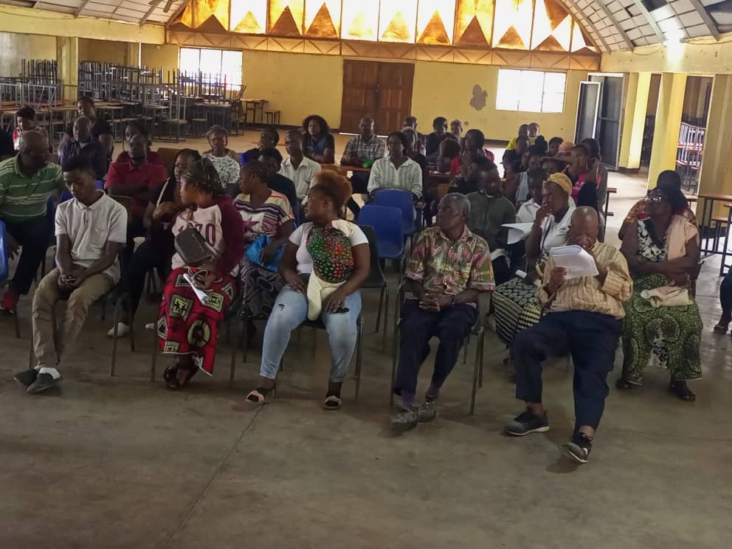
COMMUNITY MEMBERS GOING THROUGH CDF APPLICATION FORMS

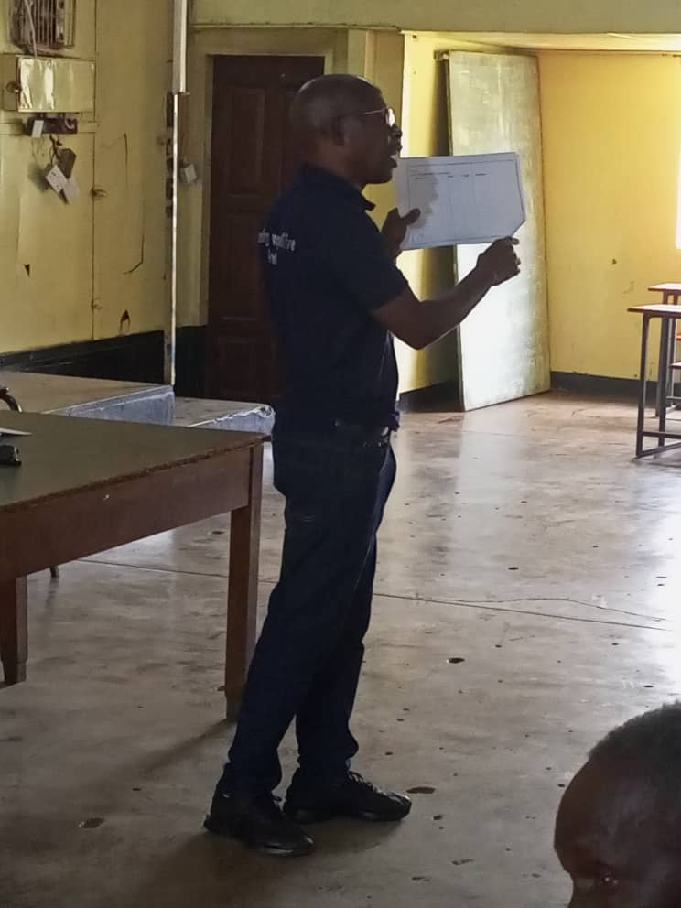
THE DOCUMENT BEING EXPLAINED TO THE COMMUNITY MEMBERS ATTENDING THE MEETIING AT LIBALA SECONDARY SCHOOL.
PREPARED BY: CHECKED BY:
VISASI PHIRI THERESA KASANI

