LUSAKA CITY COUNCIL
CITY PLANNING DEPARTMENT
REPORT ON THE EXHIBITION OF CDF COMPONENTS AT THE 97TH AGRICULTURAL AND COMMERCIAL SHOW HELD ON 30TH JULY 2025 – 4TH AUGUST 2025.


REPORT ON THE EXHIBITION OF ALL CDF COMPONENTS AT THE JUST ENDED 97TH AGRICULTURAL AND COMMERCIAL SHOW UNDER THE THEME ADAPTING TO CLIMATE CHANGE.
The show society of Zambia is an organization that promotes and showcases businesses from Zambia and within the region under the Zambia agricultural and commercial show. It began in 1919 and has since been held every year.
The Agricultural and Commercial Show provides a platform for Local and international businesses to exhibit their products and services to the general public and other stakeholders. The Show highlights innovations and creativity from various Organizations.
This year’s Show was celebrated under the theme – Adapting to Climate Change which was officiated by our Republican President H.E President Hakainde Hichilema and graced by his Botswana counterpart President Duma Boko.
In his speech H.E President Hakainde Hichilema thanked the local farmers and the small and medium enterprises on the impact they have made towards agricultural sustainability which has seen the Country achieve the largest yields expressed this year since Independence.
The President also highlighted the need to focus on irrigation so that climate change ravages can be mitigated appropriately.
The Lusaka City Council under the District Planning Unit showcased the CDF components for the first time at this year’s 97th Agricultural and Commercial Show under the theme – Adapting to Climate Change which began on 30th July to 4th August 2025. The CDF exhibitors comprised of officers from all the 7 Constituencies namely;
- Chawama Constituency
- Kanyama Constituency
- Kabwata Constituency
- Lusaka Central Constituency
- Munali Constituency
- Mandevu Constituency
- Matero Contituency.
The team of officers showcased all the CDF Components namely;
- Skills Bursaries
- Secondary School Bursaries
- Empowerment Loans and Grants.
- Community Projects. (Shows goers were encouraged to take keen interest in knowing their zonal leaders to enable them participate fully in the identification of projects in their respective areas of residence to help foster development at large.
A total number of about 615 brochures and 385 applications were distributed at the just ended 97th Agricultural and Commercial Show. Below is the breakdown:
- Skills Bursaries – 201 application forms
- Secondary School Bursaries – 50 application forms
- Empowerment Loans – 88 application forms
- Empowerment Grants – 46 application form.
CHALLENGES FACED
- Limited funding despite having funds in the CDF accounts.
- Less coverage of the CDF officers during the Show by Public Relations
- Late payment of items for the show delayed the preparation of the stand.
- Disunity among Lusaka city council exhibitors and officers exhibiting at CDF Corner.
SUCCESS ACHIEVED
- A good number of people visited the CDF stand to enquire more about CDF.
- The CDF stand was well branded and visible.
- The officers were all in attendance.
RECOMMENDATIONS
- A representative from the WDC office to be part of the team attending the Show next year.
- Allowances to be paid on time.
- Logistics to be made and done before hand.
- All participating departments to work together as a team.
- More coverage on the CDF desk.
In conclusion, the Show was well exhibited, successful and well attended by all the officers from the 7 Constituencies. The CDF components and procedures were well explained to the members of the general public and the show goers.

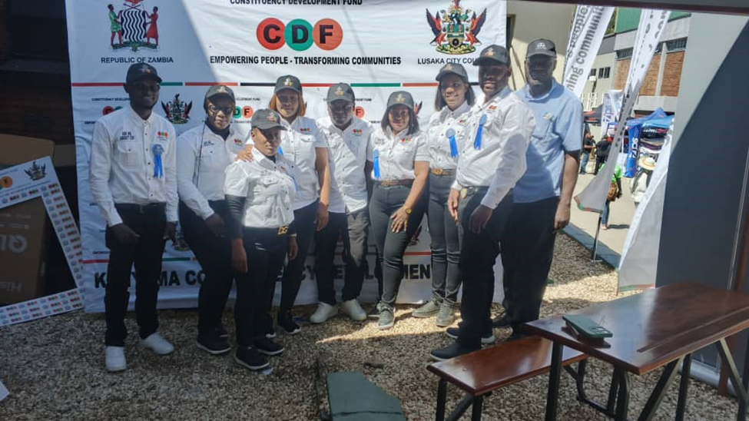

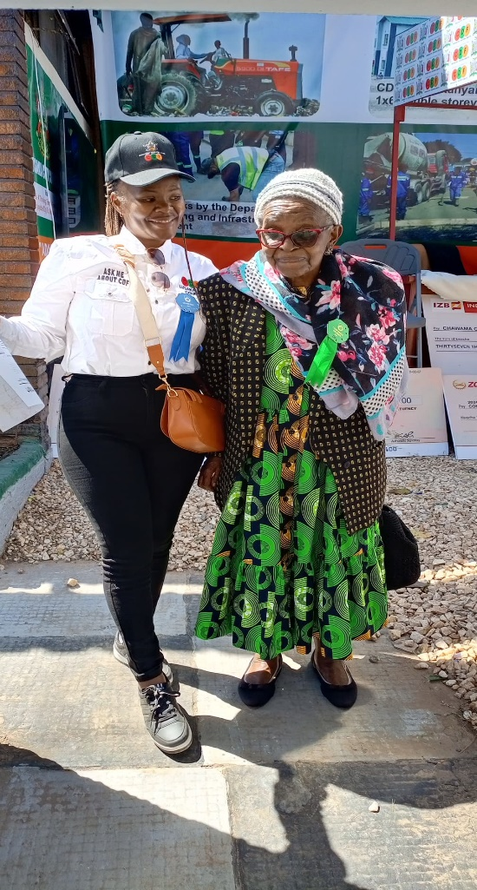
A picture of Ms Chileshe former Chief Administrative Officer at the CDF stand (above).


Students with a Mandevu officer enquiring about skills development at CDF stand.
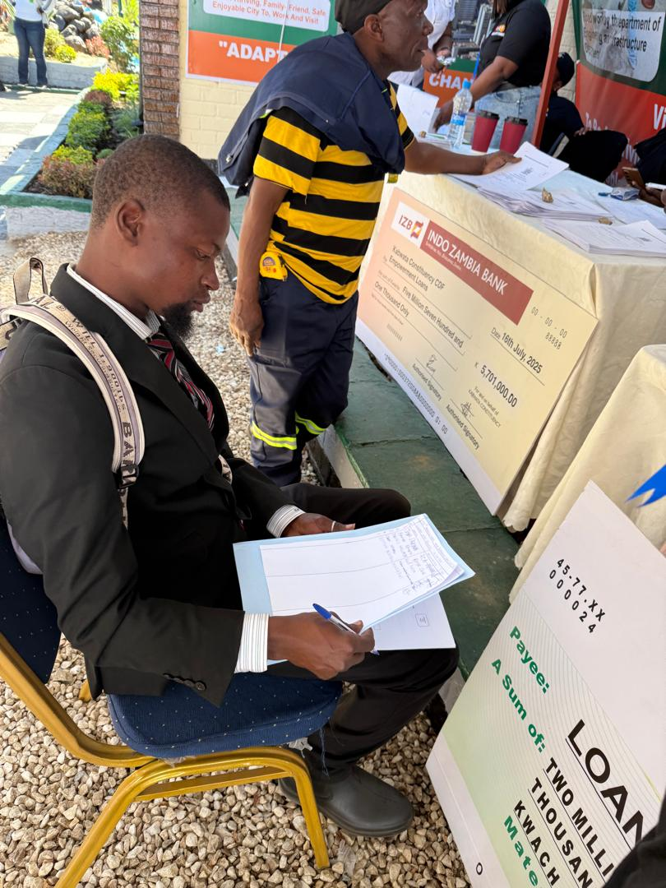
Differently abled individual enquiring about Skills training.
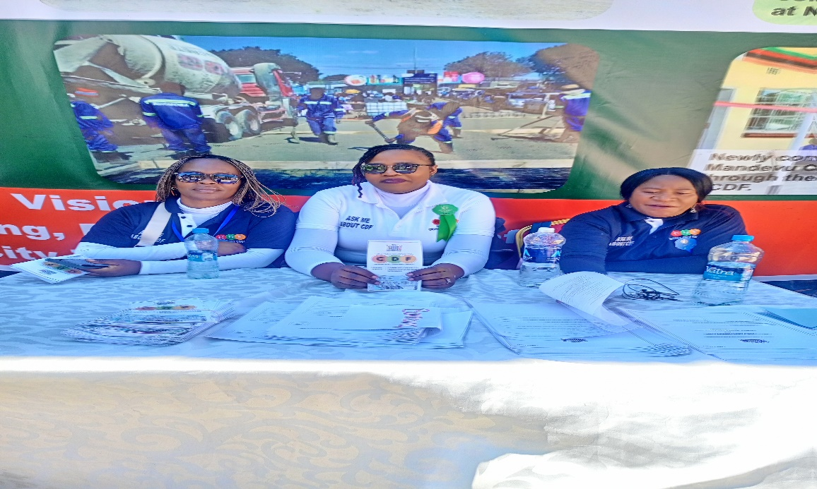
Officers waiting for general members for enquiries


Assistant Director Forward Planning visited the Stand.

Prepared by : Checked by:
Cynthia Ngoma
Caroline Mwaba
Claudia Mulenga

